**Simple RNN :**

ANN cannot be used for text summarization or time series use cases as it cannot handle below scenarios

1. Ignore word order
2. Processes everything at once and hence the context of sentence is not maintained

**Introducing RNN (Recurrent Neural Network)**

To solve this, researchers developed **RNNs**, which handle **sequential data**.

**✅ What RNN Does:**

* Takes **one word at a time** as input.
* Maintains a **memory (context)** of previous words using a feedback loop.
* This allows it to understand the **meaning based on order**.

**How RNN Works (Architecture)**

An RNN has:

1. **Input layer** – receives one word (as a vector)
2. **Hidden layer** – performs calculations and stores context
3. **Output layer** – gives final prediction (like positive/negative)

Unlike ANN, the **hidden layer** sends information **back to itself** after each step **(feedback loop),**  
allowing the network to “remember” what came before.

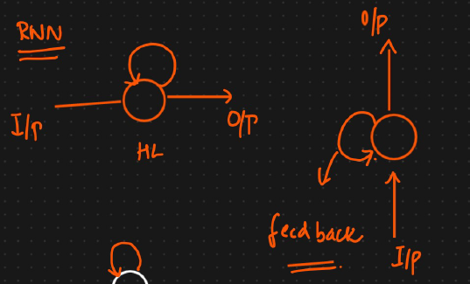

What ever output we are getting from hidden layer, will be stored in that neuron and also same output sent and stored in all other neurons in that hidden layer

The key feature of an RNN is a **feedback loop**. This loop allows the network to have a form of "memory."

* **How it Works (Step-by-Step):**
  1. An RNN processes a sentence **one word at a time**. Each word is processed in a "time step."
  2. At the first time step (t=1), it takes the first word (e.g., "The") and produces an output.
  3. **Here's the magic:** That output (which contains information about the first word) is then **fed back into the network** along with the *next* word (e.g., "food") at the second time step (t=2).
  4. Now, when the network processes "food," it also has the context from "The." It understands that "food" came after "The."
  5. This process repeats for every word. By the time it reaches the end of the sentence, the network has built up a contextual understanding based on all the previous words in their correct order.

This process of "unfolding" through time allows the RNN to remember the sequence and understand the context, which is exactly what was missing in the basic ANN. It effectively gives the network a memory of what came before in the sequence.

Below screenshot gives the input data and also unfolding of single neuron at different timestamps

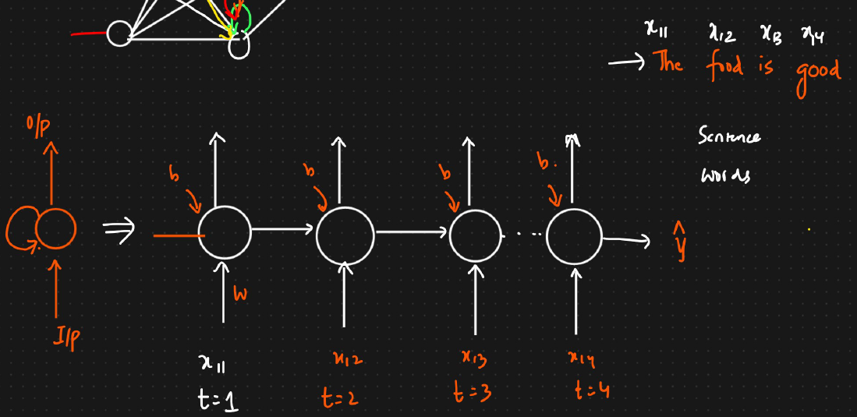

**388 Forward propagation with time in RNN training:**

**How the RNN Processes the Sentence (Forward Propagation)**

An RNN is special because it has a **memory**. It processes a sentence **one word at a time** and remembers what it has seen before. This is done through "time steps."

Let's walk through the sentence "The food is good."

* **Time Step 1: Processing "The"**
  1. The vector for "The" ([1, 0, 0, 0, 0]) is fed into the network.
  2. The network's hidden layer (the "thinking" part) processes this input and produces an output. Let's call this Output_1.
  3. Output_1 is a summary of the information from the first word.
* **Time Step 2: Processing "food"**
  1. The vector for "food" is fed into the network.
  2. **Here's the key part:** The network also receives Output_1 from the previous step.
  3. The hidden layer now processes **both** the new word ("food") and the memory of the previous word ("The").
  4. It produces a new output, Output_2, which contains the combined context of “The food”.
* **Time Step 3: Processing "good"**
  1. The vector for "good" is fed into the network.
  2. The network also receives Output_2 (the memory of "The food").
  3. The hidden layer processes the new word ("good") and the memory of the previous words.
  4. It produces Output_3, which now understands the context of the entire phrase "The food good".
  5. This step-by-step process, where the output from one step becomes an input for the next, is how an RNN reads a sentence and builds up an understanding of the sequence.

**Part 3: The Math Behind It (Simplified)**

The lesson also explains the calculations happening inside the network.

* 1. **Weights and Biases:** The network has internal numbers called **weights** and **biases**. These are the parameters that the network "learns" during training to make better predictions. There are two main sets of weights:
  2. W: Weights for the new word input.
  3. W_dash: Weights for the memory (the output from the previous step).

**The Formula at Each Step:** The calculation for the output at any given time step looks like this:

New_Output = Activation_Function( (Current_Word * W) + (Previous_Output * W_dash) + Bias )

* + - This formula combines the information from the current word and the memory from the previous step.
    - The Activation_Function (like Sigmoid or Tanh) helps the network process the information in a non-linear way, which is crucial for learning complex patterns

**Part 4: Getting the Final Prediction**

* + - After processing the last word in the sentence, the final output from the hidden layer contains the contextual meaning of the entire sentence.
    - This final output is then passed to a final layer (e.g., a **Sigmoid** function for a yes/no answer like positive/negative) to produce the final prediction (e.g., a number close to 1 for "positive").
    - The network then compares its prediction to the correct answer, calculates the error (the "loss"), and uses a process called **backpropagation** to adjust its weights and biases to become more accurate next time. The lesson mentions that backpropagation will be covered in the next video.

**Step 4 – Forward Propagation Logic**

Now, let’s see **how calculations happen** inside RNN:

**At Time Step 1 (t=1)**

* Input: **x₁₁** = “The”
* Multiply by weight matrix **W**
* Add bias **b**
* Apply activation function **f** (like tanh or ReLU)

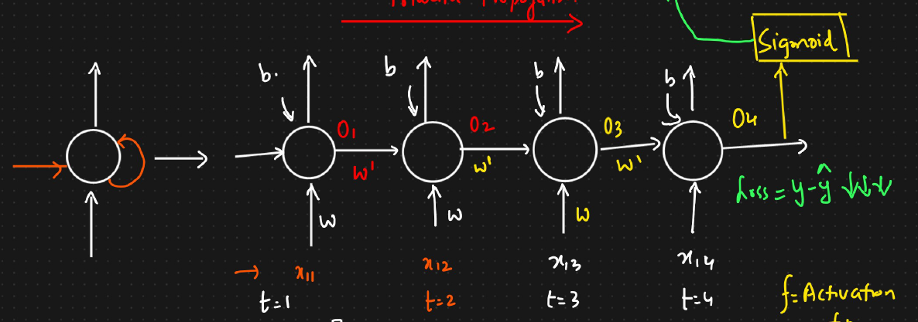

**Below is the example screenshot of single same neuron but at different timestamps. Weights will not get updated during forward propagation and this weights will get updated during backward propagation**

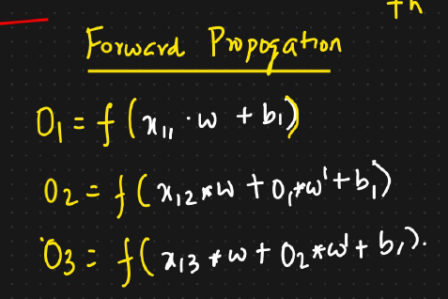

**Formula:**  
h₁ = f(W * x₁₁ + b)

The output **h₁** is passed to:

* The next time step (as memory)
* Itself (feedback loop)

**At Time Step 2 (t=2)**

* Input: **x₁₂** = “food”
* It considers **current input** + **previous hidden output (h₁)**

**Formula:**  
h₂ = f(W * x₁₂ + W' * h₁ + b)

Here:

* W → weights for input
* W' → weights for previous hidden output (feedback loop)
* b → bias term

**At Time Step 3 and 4 (and so on)**

Each next word repeats the same process:  
hₜ = f(W * xₜ + W' * hₜ₋₁ + b)

Finally, after the last word (“good”), the RNN has learned **context from all previous words**.

**📤 7. Step 5 – Output Layer**

* After all words are processed, the **final hidden output (h₄)** is sent to the **output layer**.
* Since this is a **binary classification** problem (positive/negative), we use:

**Sigmoid activation function** → gives value between 0 and 1.

* + Close to **1** → positive sentiment
  + Close to **0** → negative sentiment

If it were a **multi-class** problem (e.g., classifying into multiple emotions), we’d use **Softmax** instead.

**🧮 8. Step 6 – Weight and Bias Calculation**

In RNN:

* Input → Hidden weights (**W**) = 5 × 3 = **15 weights**
* Hidden → Hidden weights (**W’**) = 3 × 3 = **9 weights**
* Hidden → Output weights (**Wₒ**) = 3 × 1 = **3 weights**
* Biases = 3 (hidden layer) + 1 (output) = **4 biases**

✅ **Total trainable parameters = 15 + 9 + 3 + 4 = 31**

These are adjusted during **training** (in Backpropagation, explained in the next video).

**9. Step 7 – Overall Forward Propagation Formula**

For each time step *t*,

hₜ = f(W * xₜ + W' * hₜ₋₁ + b)

yₜ = activation(Wₒ * hₜ + bₒ)

Where:

* xₜ = input vector at time t
* hₜ = hidden state (memory)
* f() = activation function
* yₜ = output (prediction)

**🧩 10. Step 8 – Computing Loss**

After prediction (ŷ), we calculate:  
Loss = (Actual Output – Predicted Output)²  
This error (loss) helps the model learn — it will later be minimized using **Backward Propagation Through Time (BPTT)** (covered in the next lesson).

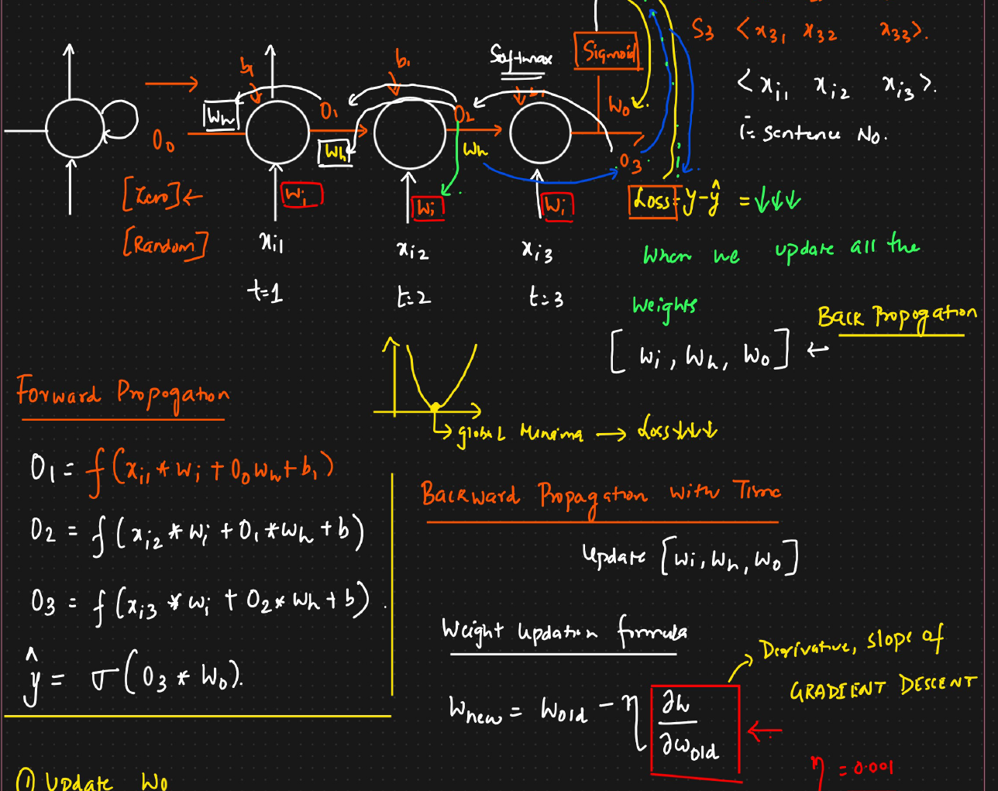

**389 Backward propagation with time in RNN training:**

Imagine an RNN reading the sentence "The food is good" to decide if it's a positive review.

1. **One Word at a Time:** The RNN reads the sentence one word at a time, in sequence. Each word is a "time step."
2. **Memory:** At each step, the network takes two things: the current word and a "memory" of the words it has already seen.
3. **Weights:** The network uses three types of internal "dials" called **weights** to process the information:
   * W_i: Weights for the **input** word.
   * W_h: Weights for the **hidden memory** from the previous step.
   * W_o: Weights for the final **output** prediction.
4. **Final Prediction:** After reading the last word, the network uses its final memory state and the output weights (W_o) to make a final prediction (e.g., "Positive").

**Part 2: The Goal - Learning from Mistakes**

1. **Calculate the Error (Loss):** After making a prediction, the network compares its answer to the correct answer. The difference between them is the **error** or **loss**.
2. **The Goal:** The main goal is to reduce this error to zero.
3. **How to Reduce Error:** To get better, the network needs to adjust its internal dials (the weights W_i, W_h, and W_o).
4. **Gradient Descent:** The process of figuring out *how much* and in *which direction* to turn these dials is called **gradient descent**. The key is to calculate the "gradient," which is just a measure of how much each weight contributed to the final error.

**Part 3: Backpropagation Through Time (BPTT) - Adjusting the Dials**

BPTT is the process of going backward from the final error, through all the time steps, to figure out how to adjust each weight. It uses a math concept called the **chain rule**, which helps trace the error back to its source.

The network updates its three sets of weights one by one, starting from the end and moving backward.

**Step 1: Updating the Output Weights (W_o)**

* **What it is:** This is the easiest weight to update. It was only used once, right at the end, to make the final prediction.
* **How it's done:** The network calculates how much W_o directly contributed to the final error. The chain is very short: Error -> Prediction -> W_o.
* The weight is then adjusted based on this calculation.

**Step 2: Updating the Hidden Weights (W_h)**

* **What it is:** This is more complicated. The hidden weight W_h was used at **every single time step** to pass the memory forward.
* **How it's done:** To get the total impact of W_h on the error, the network has to calculate its contribution at each time step and **add them all up**.
  + **At the last step (t=3):** It calculates the error contribution through the chain: Error -> Prediction -> Memory_at_step_3 -> W_h.
  + **At the middle step (t=2):** The chain is longer. The error has to flow back from step 3 to step 2: Error -> Prediction -> Memory_at_step_3 -> Memory_at_step_2 -> W_h.
  + **At the first step (t=1):** The chain is the longest, flowing all the way back from the end: Error -> ... -> Memory_at_step_2 -> Memory_at_step_1 -> W_h.
* The total gradient for W_h is the sum of the gradients from all these steps. This is why it's called "Backpropagation **Through Time**"—the error signal literally travels back through the network's timeline.

**Step 3: Updating the Input Weights (W_i)**

* **What it is:** This is similar to updating W_h. The input weight W_i was also used at every time step to process each new word.
* **How it's done:** Just like with W_h, the network calculates the contribution of W_i to the final error at each time step and adds them up.
  + **At the last step (t=3):** The chain is Error -> Prediction -> Memory_at_step_3 -> W_i.
  + **At the middle step (t=2):** The error flows back: Error -> ... -> Memory_at_step_2 -> W_i.
  + **At the first step (t=1):** The error flows all the way back: Error -> ... -> Memory_at_step_1 -> W_i.
* The total gradient is the sum of these individual calculations.

**In order to reduce the loss we need to update all the weights. In backward propagation we first need to update output weight (W_o) based on timestamp**

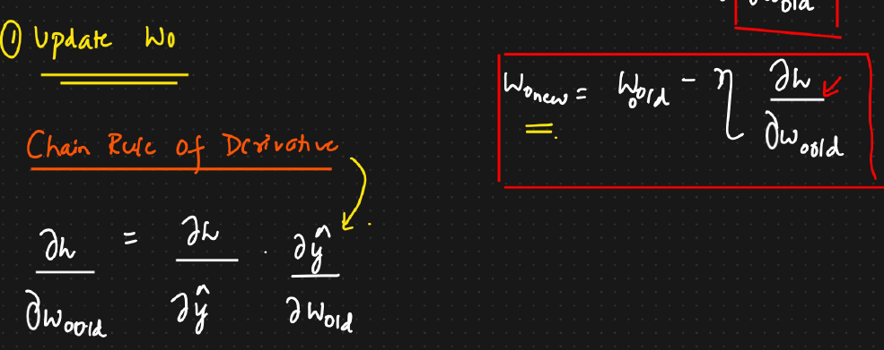

**Updating hidden layer weigiths (W_h) 🡪** This weights are available on all timestamps.

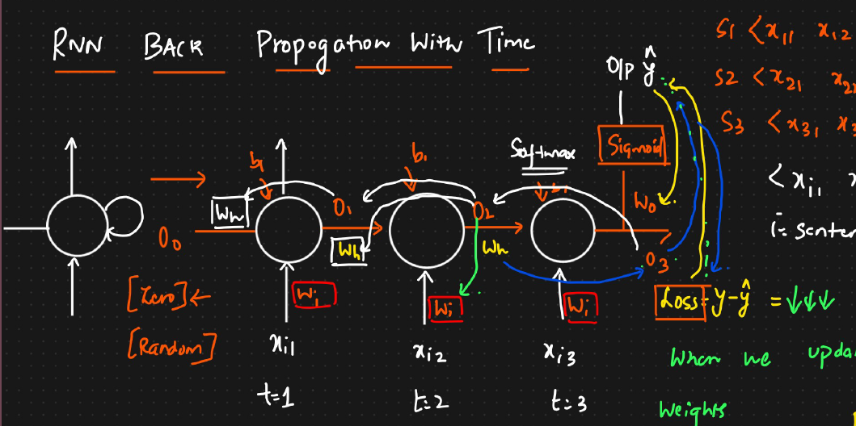

As we have three timestamps ( t = 1,2,3), we need to calculate weights at all timestamps

At t=3, the weights are dependent on following sequence ( loss is dependent on y^, y^ is dependent on O3, O3 is dependent on W_h ( t=3)).

At t=2, the weights are dependent on following sequence ( loss is dependent on y^, y^ is dependent on O3, O3 is dependent on O2,O2 is dependent on W_h ( t=2).

At t=1, the weights are dependent on following sequence ( loss is dependent on y^, y^ is dependent on O3, O3 is dependent on O2,O2 is dependent on O1,O1 is dependent on W_h ( t=1).

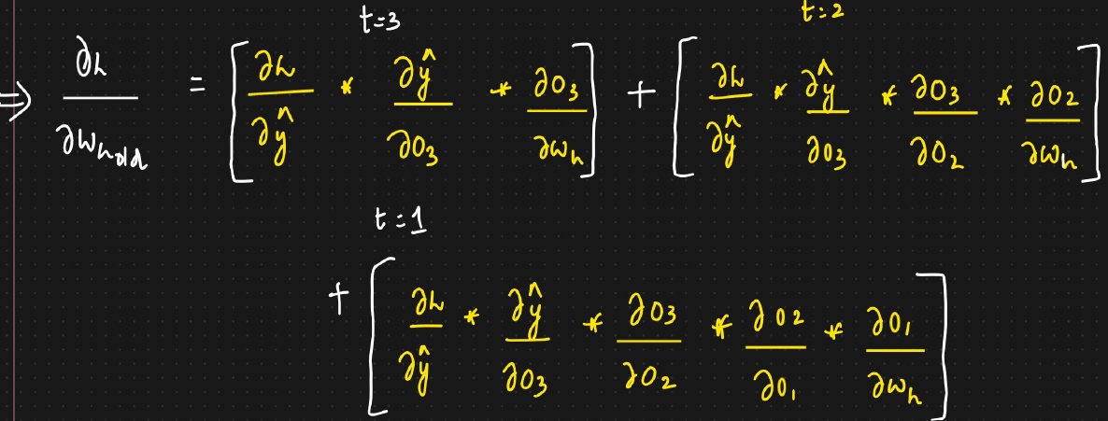

Once the hidden weights are updated we need to update input weights (W_i) based on timestamp and below is example

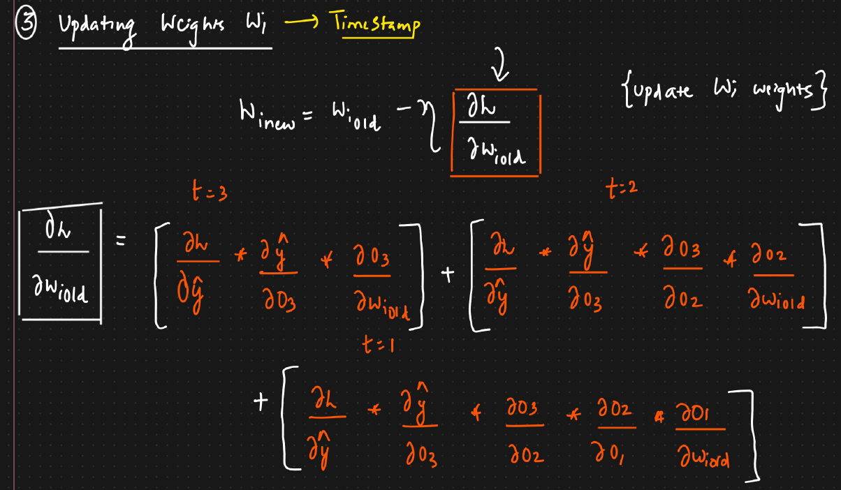

**Summary of the Process**

In one cycle of learning (one "backpropagation"), the RNN:

1. Calculates the final error.
2. Goes backward in time from the error.
3. Calculates how much each weight (W_o, W_h, W_i) contributed to that error at every point it was used.
4. Adjusts all the weights slightly to reduce the error.

This entire process (forward prediction and backward adjustment) is repeated thousands of times with many different sentences until the network's loss is very low and it becomes accurate at its task.

**390 Problems with RNN:**

When training RNNs The long term dependencies cannot be captured and hence better accuracy cannot be provided

**Vanishing Gradient Problem**

🧩 **Meaning:**  
When training RNNs using **Backpropagation Through Time (BPTT)**, gradients (the learning signals) **shrink** as they move backward through many time steps.

🔍 **Effect:**

* Early layers (older words/time steps) get **tiny updates** (near zero).
* The network **forgets long-term information**.
* It only learns from **recent inputs**.

🧮 **Technical reason:**  
During backpropagation, gradients are multiplied repeatedly by numbers less than 1 (from the derivative of activation functions like tanh/sigmoid).  
After many multiplications → gradient ≈ 0.

**2. Exploding Gradient Problem**

🧩 **Meaning:**  
The opposite of vanishing — gradients become **too large** during training.

🔍 **Effect:**

* Weight updates explode to huge values.
* Model becomes **unstable** or **diverges**.
* Loss value may suddenly become **NaN (Not a Number)**.

🧮 **Technical reason:**  
Gradients get multiplied repeatedly by numbers greater than 1 during backpropagation.

⚙️ **Solution:**  
Use **gradient clipping** (limit gradient size to a maximum threshold).

**3. Short-Term Memory**

RNNs can only remember **short sequences** effectively.  
If a dependency or context is **far back in the sequence**, it is usually forgotten.

🧠 Example:

“The book that I bought last week because it was written by my favorite author was amazing.”

RNN might remember “amazing” and “book”,  
but **forget** the connection between “book” and “author”.

**4. Difficulty in Parallelization**

🧩 **Meaning:**  
RNNs process inputs **sequentially** — one word or step after another.

🔍 **Effect:**

* Training can’t be **parallelized** efficiently (unlike CNNs or Transformers).
* Takes **more time** and **more computation** for long sequences.

💻 **Example:**  
If a sentence has 50 words, RNN must process all 50 **in order**, not simultaneously.

**5. Long Training Time**

Because of sequential dependencies and gradient issues:

* Training takes **a long time**.
* Often requires **careful tuning** of learning rate and weight initialization.

**6. Sensitive to Initialization**

RNN performance heavily depends on:

* Initial weight values
* Choice of activation function (tanh/sigmoid can worsen vanishing gradient)
* Sequence length

If initialized poorly → training can fail completely.

**7. Cannot Capture Long-Term Dependencies Well**

Even with careful training, simple RNNs fail to understand **relationships between distant words** in text.

🧠 Example:

“If it rains tomorrow, I’ll cancel the trip.”  
When predicting “cancel”, RNN might not recall the earlier “rains”.

This is why **LSTMs (Long Short-Term Memory)** and **GRUs (Gated Recurrent Units)** were developed —  
they **retain long-term information** through **gates** (input, forget, and output gates).

**8. Context Loss in Long Sequences**

As sequences get longer, RNN’s “memory” becomes blurry —  
newer words dominate the context, while older ones fade out.

This makes it **unsuitable for very long text or paragraph-level understanding**.

| **Problem** | **Description** | **Effect** |
| --- | --- | --- |
| **Vanishing Gradient** | Gradients become too small while going backward | Model forgets earlier information |
| **Exploding Gradient** | Gradients become too large | Model becomes unstable |
| **Short-Term Memory** | Can’t remember old context | Fails for long sentences |
| **Sequential Computation** | No parallel training | Slow training |
| **Long Training Time** | Due to sequential nature | Inefficient learning |
| **Sensitive Initialization** | Depends on weight setup | Unstable results |
| **Poor Long-Term Dependency** | Context fades quickly | Misses relationships between far words |
| **Context Loss** | Old info overwritten by new | Bad for long sequences |

**When we use one-hot encoding for very long sentence say 10000, in those we will arrive at sparse matrix which inturn lead to Overfitting problem**

**398 Problems with LSTM RNN (Long Short-Term Memory):**

**Limitations of simple RNNs**, mainly:

* **Vanishing Gradient Problem**
* **Long-term dependency problem**

**Feedback loop is generally for short-term memory**

**🚀 Why LSTM (Long Short-Term Memory) Was Introduced**

To solve RNN’s memory issues, **LSTM RNNs** were introduced.

**🧩 Key Idea:**

LSTM introduces a **special memory cell** that:

* Stores important information **for long periods**.
* Decides what to **keep**, **update**, or **forget**.
* Has both **short-term memory** (like RNN’s hidden state) and **long-term memory** (a new cell state).

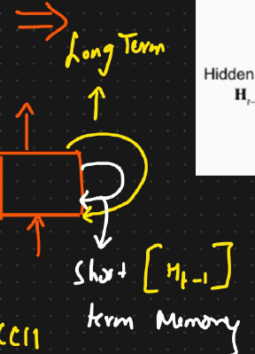

**🧮 How LSTM Works — Simple Intuition**

An **LSTM network** has:

1. **Short-term memory** → same as RNN’s hidden state (helps with recent information).
2. **Long-term memory** → a new concept that stores older, important information over time.

Both types of memory are combined to understand context better.

**🧠 Analogy – The Conveyor Belt**

The instructor compares LSTM’s **long-term memory** to a **conveyor belt at an airport**:

* The belt (memory line) keeps moving continuously.
* Workers can **add luggage** (add new information) or **remove luggage** (delete old information).
* Similarly, the **LSTM memory cell** adds or removes data depending on its importance.(add context that is needed and remove context that is not needed)

This way, useful information (like “India”) is kept until needed later (when predicting “Hindi”).

**💡 How LSTM Fixes RNN’s Problem**

* Adds a **memory cell** that carries long-term context across time steps.
* Introduces **gates** (input, forget, output) that control information flow:
  + What to **add**
  + What to **retain**
  + What to **discard**
* Keeps the gradient stable (prevents it from vanishing).

This allows the model to:  
✅ Remember useful information for long sequences  
✅ Avoid overloading memory with irrelevant data

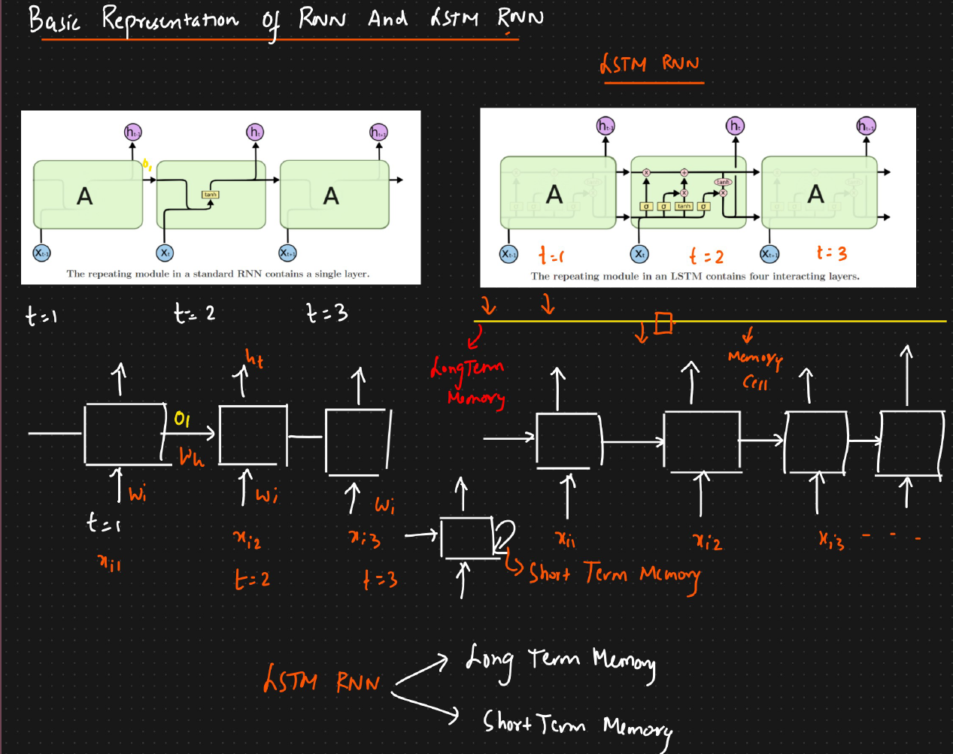

**399 LSTM RNN Architecture:**

An **LSTM unit** (the “cell”) has **three main gates** and a **memory line**:

| **Gate** | **Purpose** |
| --- | --- |
| **Forget Gate** | Decides what old information to delete from memory |
| **Input Gate and candidate memory** | Decides what new information to store |
| **Output Gate** | Decides what information to send out as the output |

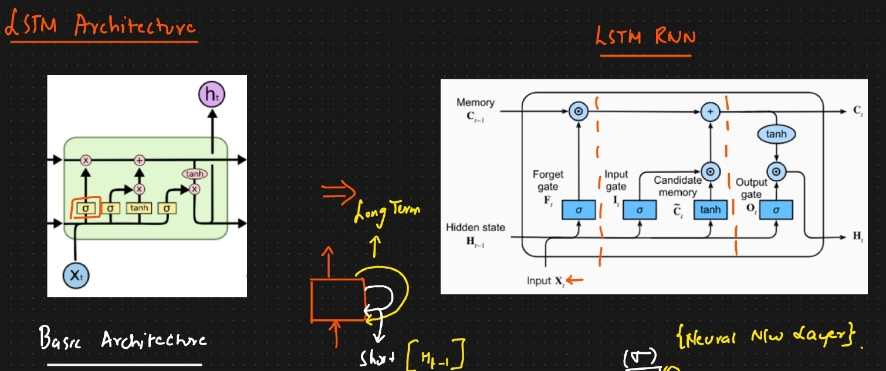

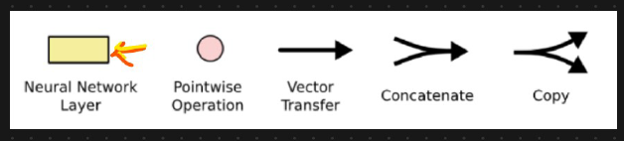

Some terminology related to LSTM RNN

**Ht-1 →** Hidden state of previous timestamp

**Xt →** Word passed as input in current timestamp

**Ct-1 →**Memory cell of previous timestamp

**Ct** → After removing and adding some context

**Wi →** Weights of inputs

**Wc →** Weights of memory cells

**Wo →** Weights of output

**400: Forget gate in LSTM RNN:**

The document explains a key component of a Long Short-Term Memory (LSTM) neural network called the **"forget gate."** LSTMs are often used for tasks involving sequences of data, like predicting the next word in a sentence. The forget gate's main job is to decide which information from the past is no longer relevant and should be "forgotten."

**1. The Goal: Deciding What to Forget**

Imagine you are reading a long story. As you move from one sentence to the next, the context might change. For example:

* **Sentence 1:** "John is playing football."
* **Sentence 2:** "Now, he is eating an apple."

When processing the second sentence, the fact that John was playing football might not be important anymore. The LSTM needs a way to discard the "football" context and focus on the "eating" context. This is what the forget gate does. It looks at the new information (the current word) and the context from the previous step to decide what to keep and what to throw away from its long-term memory.

**1. The Goal: Deciding What to Forget**

Imagine you are reading a long story. As you move from one sentence to the next, the context might change. For example:

* **Sentence 1:** "John is playing football."
* **Sentence 2:** "Now, he is eating an apple."

When processing the second sentence, the fact that John was playing football might not be important anymore. The LSTM needs a way to discard the "football" context and focus on the "eating" context. This is what the forget gate does. It looks at the new information (the current word) and the context from the previous step to decide what to keep and what to throw away from its long-term memory.

**2. The Inputs to the Forget Gate**

To make its decision, the forget gate uses two pieces of information at each step (or for each word):

1. **The Current Word (x_t):** The new word being processed. Computers don't understand words, so the word is converted into a list of numbers called a **vector**.
2. **The Previous Hidden State (h_{t-1}):** This is the output from the *previous* step of the LSTM. It acts as a short-term memory, holding context from the immediately preceding words. This is also a vector.

These two vectors are combined into one larger vector.

**3. How the Forget Gate Works**

The process can be broken down into a few steps:

1. **Combine Inputs:** The vector for the current word and the vector from the previous hidden state are joined together.
2. *Example:* If the word vector has 4 numbers and the previous state has 3, they are combined to form a single vector with 7 numbers.
3. **Neural Network Layer:** This combined vector is passed through a small, simple neural network layer. This layer learns, through training, which patterns in the input are important.
4. **Sigmoid Activation:** The output from the neural network is then passed through a **sigmoid function**. This is the most crucial part. The sigmoid function takes any number and squishes it into a value between **0 and 1**.
   * + A value close to **0** means "forget this completely."
     + A value close to **1** means "keep this completely."
     + A value in between (like 0.5) means "partially forget this."

The result is a new vector, called the **forget vector (f_t)**, filled with numbers between 0 and 1.

**4. Applying the Decision: Updating the Memory**

The LSTM has a long-term memory called the **cell state (c_{t-1})**. The forget vector (f_t) is used to update this memory.

This is done through a simple element-wise multiplication:

* + - The LSTM takes the old memory (c_{t-1}).
    - It multiplies each number in the old memory vector by the corresponding number in the forget vector (f_t).

Let's look at three scenarios:

**Scenario 1: Forget Everything**

* + - If the forget vector is [0, 0, 0], multiplying it with the old memory will result in [0, 0, 0].
    - **Meaning:** The context has completely changed. The model is told to erase all of its previous long-term memory.

**Scenario 2: Keep Everything**

If the forget vector is [1, 1, 1], the old memory remains unchanged after multiplication.

* + - **Meaning:** All the previous information is still relevant for the current step.

**Scenario 3: Partially Forget**

If the forget vector is [0.5, 1, 0], the model will:

* + - Reduce the importance of the first piece of information by 50%.
    - Keep the second piece of information fully.
    - Completely forget the third piece of information.

In conclusion, the **forget gate** acts as a dynamic filter for the LSTM's memory. By analyzing the new input and the recent context, it generates a set of signals (between 0 and 1) that tell the memory cell exactly which pieces of old information to discard, keep, or reduce in importance, allowing the network to adapt to changing contexts in a sequence.

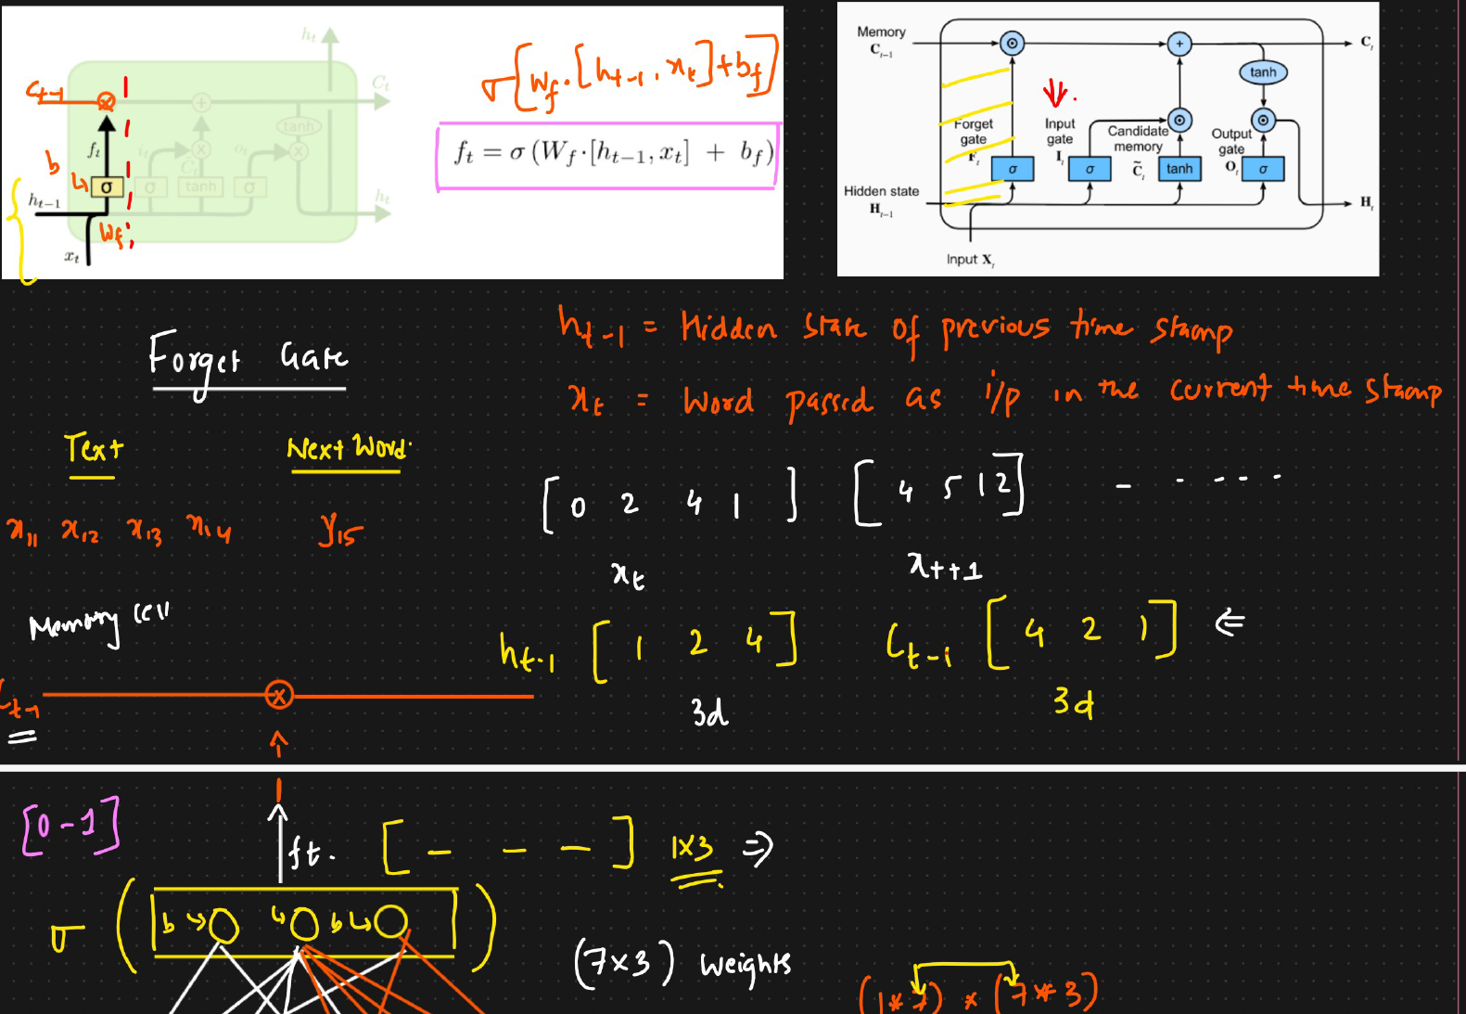

**If the hₜ₋₁ is three dimension then Cₜ₋₁). should also be three dimensions**

**xₜ (which is four dimension)& hₜ₋₁ will be concatenated together and we will get seven dimension and this is fed into neural network and then a activation function is applied on the target and finally we will be getting fₜ and this will be combined with pervious timestamp memory cell with pointwise multiplication operation . If the output is 1 then this word will be added to longterm memory and if the output is 0 then this word will be forgot and it is 0.5 then it is partial added to long term memory cell**

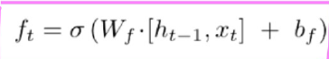

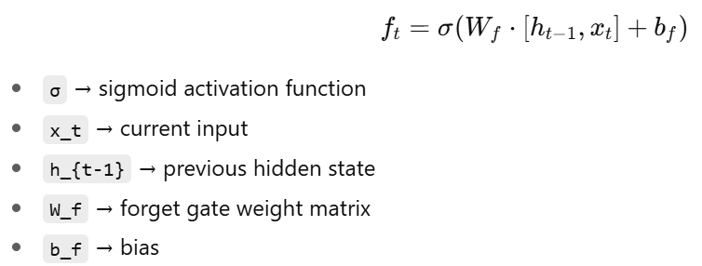

**From ChatGPT GO**:

**🧩 3. Inputs to the Forget Gate**

At each time step t, the Forget Gate takes two main inputs:

1. **xₜ** → The current input (e.g., the current word or feature vector)
2. **hₜ₋₁** → The previous hidden state (short-term memory from the last step)

These two are **combined (concatenated)** into one vector and passed through a **small neural network layer** that uses the **sigmoid (σ)** activation function.

**🔢 4. Example Dimensions (for Understanding)**

Let’s assume:

* Each input word (**xₜ**) is represented as a **4-dimensional vector** → [0, 2, 4, 6]
* The previous hidden state (**hₜ₋₁**) is a **3-dimensional vector** → [1, 2, 4]

When we **concatenate** them → we get a **7-dimensional input vector**.

So, the Forget Gate has **7 input values** going into its small neural layer.

If the hidden layer has **3 neurons**, then:

* Weight matrix size = 7 × 3
* Output of the gate (**fₜ**) = 1 × 3 vector (three values)

These three outputs (between 0 and 1) decide **how much of the old memory to keep or forget**.

**🔄 5. Activation Function Used**

The **sigmoid function** is used in the Forget Gate.  
It outputs values **between 0 and 1** for each component in the vector:

* **0 → completely forget this information**
* **1 → keep this information**
* **0.5 → keep half / forget half**

**🧮 6. Pointwise Multiplication with the Cell State**

Once the Forget Gate outputs its result (**fₜ**), we multiply it **pointwise (element-by-element)** with the previous **cell state (Cₜ₋₁)**.

This operation decides what part of the **old memory** remains in the current cell.

**Example:**

Let’s say:

* Previous cell state (**Cₜ₋₁**) = [6, 8, 9]
* Forget gate output (**fₜ**) = [0, 0, 0]

Then:

[6, 8, 9] × [0, 0, 0] = [0, 0, 0]  
→ Forget **everything** from previous memory.

If:

* **fₜ = [1, 1, 1]**  
  → Keep everything → [6, 8, 9] × [1, 1, 1] = [6, 8, 9]

If:

* **fₜ = [0.5, 1, 0.5]**  
  → Keep some parts, forget others → [6×0.5, 8×1, 9×0.5] = [3, 8, 4.5]

This way, LSTM can **selectively remember or forget** parts of old memory depending on the context.

**🧭 7. Why Forgetting Is Important**

Forgetting helps the model **adapt to new information**.  
If the context of the input changes, older information might no longer be useful.

**Example:**

When processing text:

* Sentence: “I grew up in India … I speak fluent Hindi.”  
  → Keep “India” in memory (context is useful).
* Sentence changes: “I went to a restaurant … the food was delicious.”  
  → Forget “India” (not relevant anymore).

The forget gate automatically handles this by setting low (near 0) or high (near 1) weights based on context.

**401: Input gate and candidate memory in LSTM RNN:**

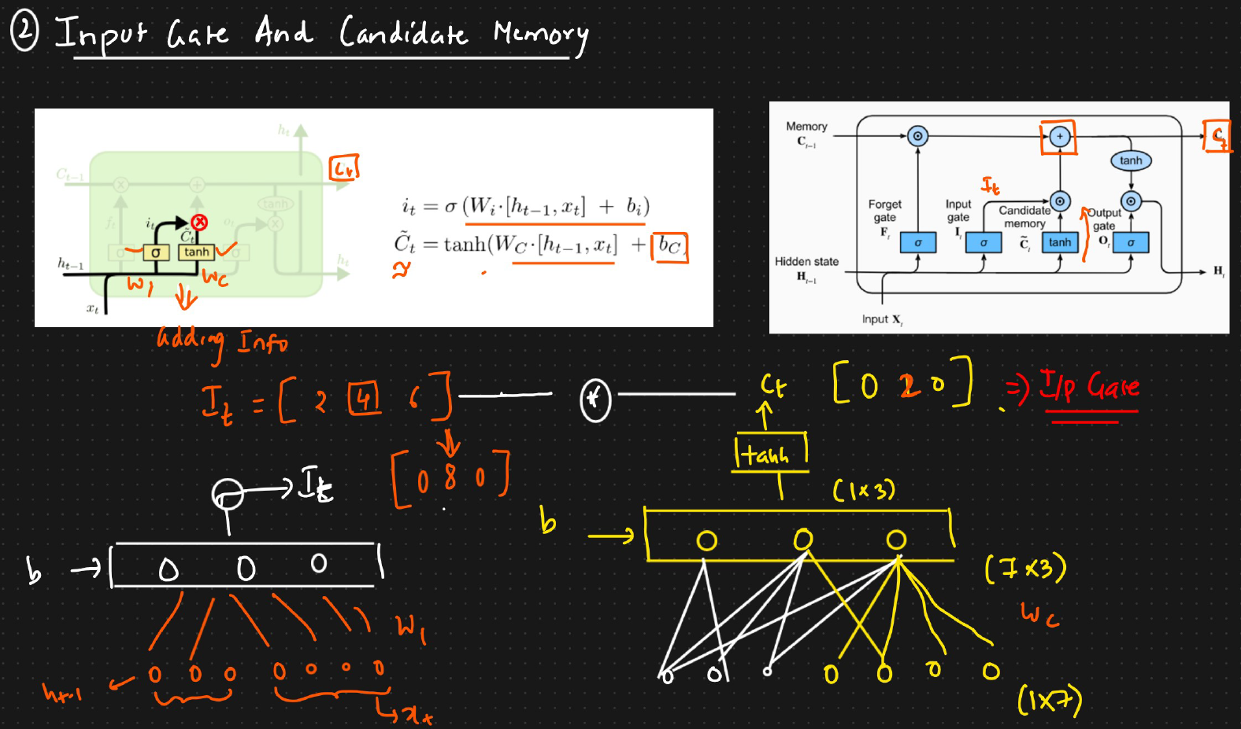

There are two parts of an input LSTM cell:

* **Input Gate**
* **Candidate Memory (also called Candidate Cell State)**

Both together help the LSTM **add new information** to the memory cell based on the current context.

**🧩 3. Input Gate — Purpose**

The **Input Gate** decides **what new information should be added** to the memory cell.  
It works in two steps:

1. **Decide which information to add** (through the gate).
2. **Create the new information** (through the candidate memory).

**⚙️ 4. Step 1 — Calculating the Input Gate**

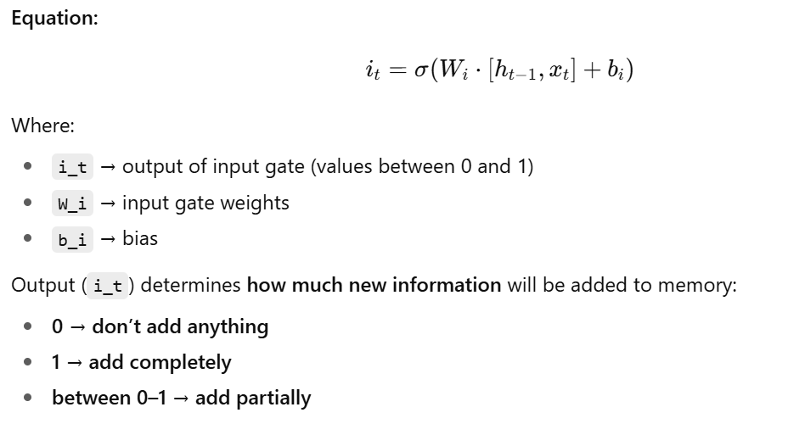

**⚙️ 5. Step 2 — Calculating the Candidate Memory**

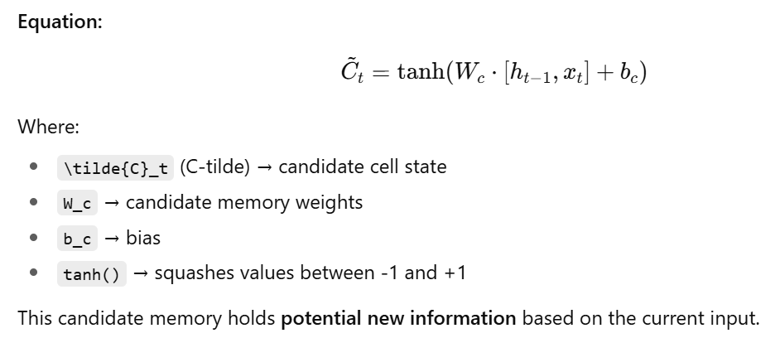

**🧮 7. Step 4 — Updating the Cell State (Final Memory)**

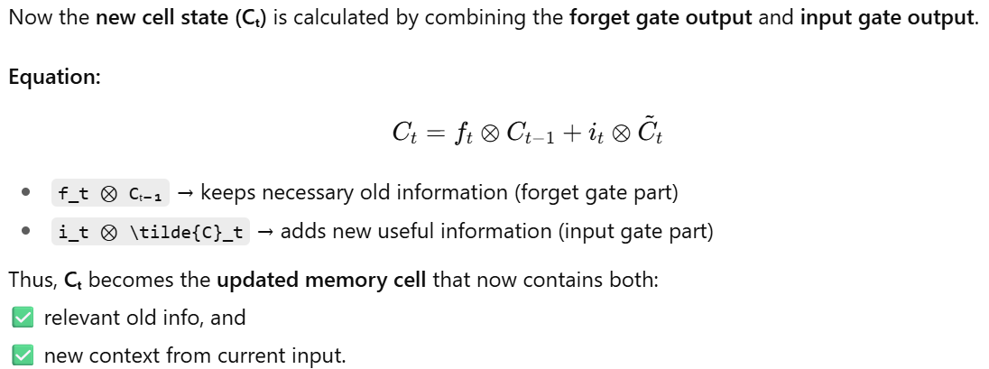

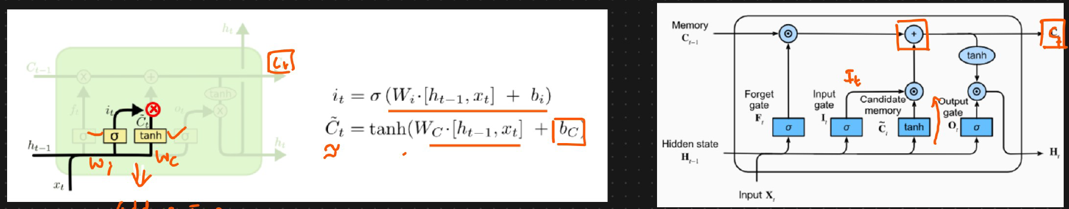

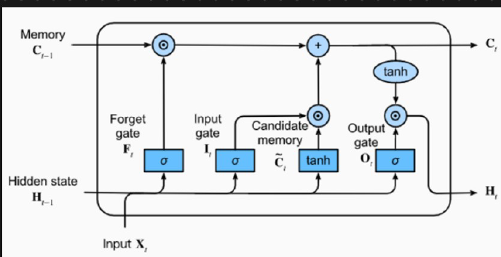

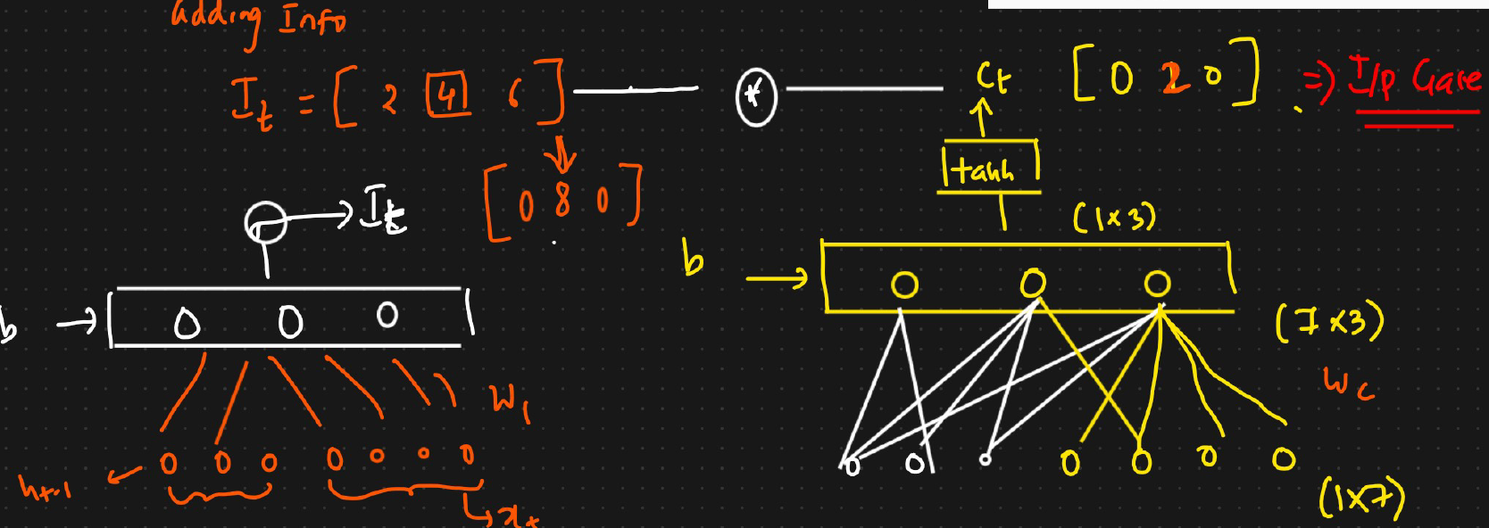

**We will first calculate the input weights which is same as forget gate but only the weights and bias will change**

**Same goes for candidate memory but the activation function, weights and bias will change. Below are the formulas**

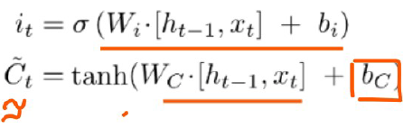

**We combine both i_t and {C}_t using point wise multiplication operation and the output of this is actually called as input gate.**

**From here based on context if any new information needed to added in the memory cell (Ct−1​) then the information will be added . And from here we will final Ct. So the final memory state is formula is given as below**

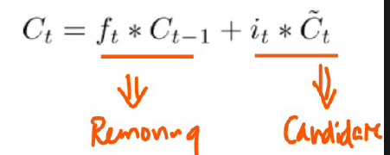

**402: Output gate in LSTM RNN:**

focusing on the **Output Gate** — the third and final main component of the LSTM cell.

The **Output Gate** determines what information from the LSTM’s **cell state (Cₜ)** should be sent out as the **hidden state (hₜ)** — the short-term memory.

* The LSTM memory cell (Cₜ) contains all the information it has learned so far.
* The Output Gate decides what portion of that knowledge to share at the current step.

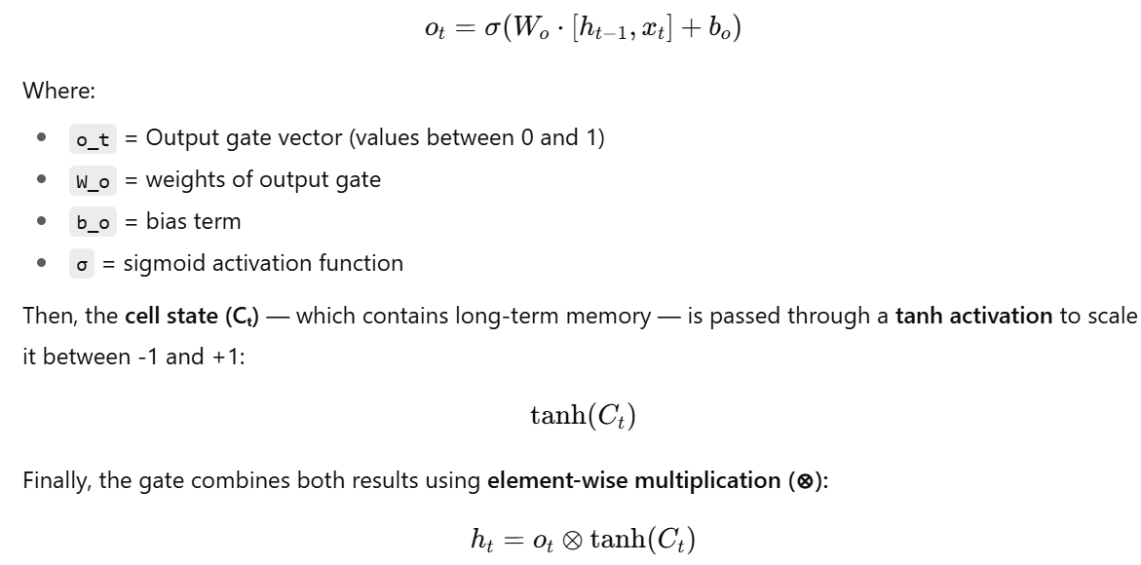

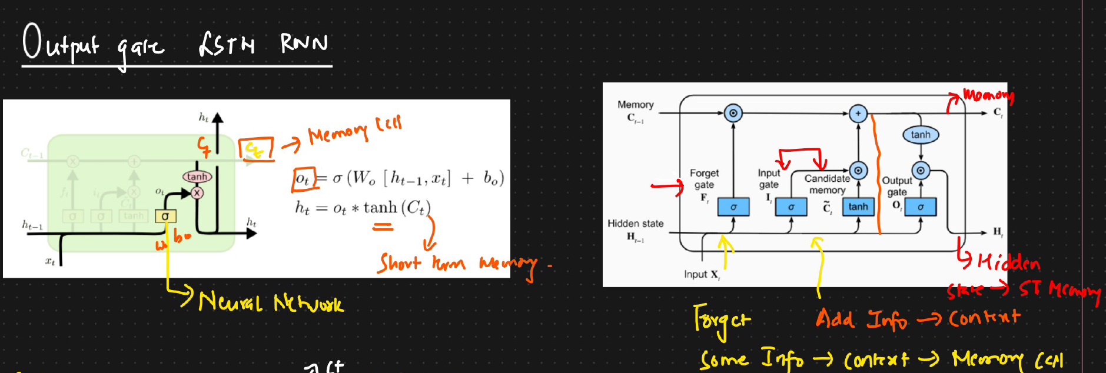

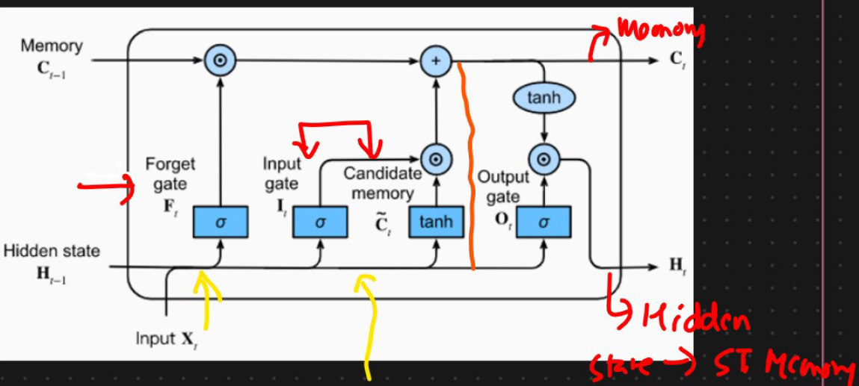

The pervious hidden state along with the current input word is passed to sigmoid activation function with weights Wo & bias bₒ

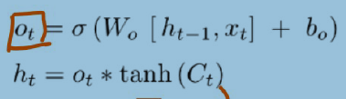

The output from input & candidate gate will be passed to neural network and output is passed to tanH activation function and this output performs point wise multiplication operation with output information and finally produces ht ( hidden state of current timestamp) which is part of short term memory.

Below diagram has multiple LSTM RNN at various timestamps and from each neurons we may add / remove some information based on the context

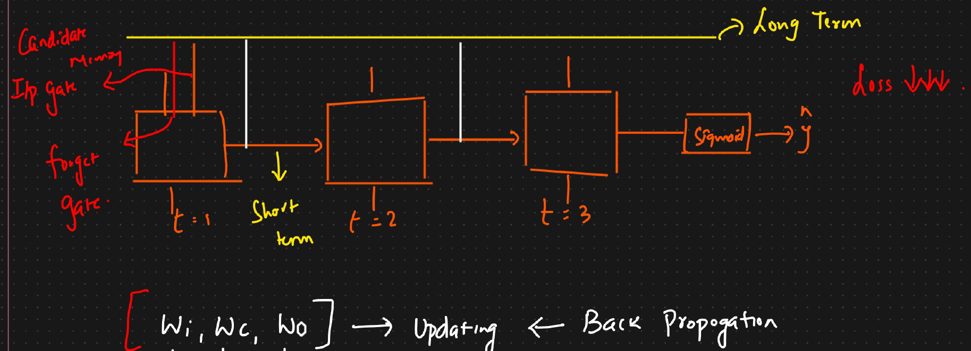

The forward and backward propagation keeps happening until loss is minimum and During back propagation **Wi** → Input gate, **Wc** → Candidate memory,**Wo** → Output gate are updated

**403: Training process in LSTM RNN:**

**1. The Example**

* **The Input Text:** A paragraph reviewing a burger. The review is complex:
  + It starts positive: "The burger looked tasty and crispy."
  + It turns negative: "But burger is not good for health. It has a lot of fats, cholesterol."
  + It ends positive again: "But this burger was made with whey protein and only vegetables were used, so it was good."
* **The Desired Output:** The final label is 1, which means the review is **good**.
* **The Challenge:** How does the machine read this whole paragraph, understand the changing context, and arrive at the correct final conclusion ("good")?

**2. Step 1: Turning Words into Numbers (Word Embeddings)**

A computer can't understand words like "tasty" or "burger." The first step is to convert every single word into a list of numbers, called a **vector**. This process is called **word embedding**.

The speaker imagines a simple 3-number vector for this example. Each number represents the word's

1. How "good" is the word?
2. How "bad" is the word?
3. How "healthy" is the word?

For example:

* The word **"tasty"** might be converted to a vector like [0.9, 0.0, 0.1]. (High on "good", low on "bad", slightly "healthy").
* The word **"fats"** might be converted to [0.1, 0.8, 0.0]. (Low on "good", high on "bad", not "healthy").

**3. Step 2: Processing the Review Word-by-Word**

The LSTM reads the review one word (or one vector) at a time. As it reads, it uses its special "gates" (Forget, Input, Output) to manage its memory. The LSTM has two kinds of memory:

* **Long-Term Memory (Cell State):** The main memory that holds the overall context.
* **Short-Term Memory (Hidden State):** A summary of what's important right now.

Here’s how the LSTM processes the example review:

1. **"The burger looked tasty and crispy."**
   * The LSTM reads these words. The vectors for "tasty" and "crispy" have high "good" values.
   * The **Input Gate** sees this positive information and decides to **add it** to the long-term memory. The memory now holds the idea: "The burger is good."
2. **"But burger is not good for health. It has a lot of fats..."**
   * Now, the LSTM reads words with negative meanings. The vectors for "not good" and "fats" have high "bad" values.
   * This creates a **context switch**.
   * The **Forget Gate** might decide to **reduce the importance** of the "tasty" information it stored earlier.
   * The **Input Gate** will **add** this new negative information ("unhealthy," "bad") to the memory. The memory now holds a mixed message: "It was tasty, but it's unhealthy."
3. **"But this burger was made with whey protein and only vegetables..."**
   * This is another, more powerful **context switch**. The words "whey protein" and "vegetables" have very high "good" and "healthy" values in their vectors.
   * The **Forget Gate** now gets a strong signal to **forget the negative information** about "fats and cholesterol." Why? Because the new information ("made with whey protein") directly contradicts and overrides it.
   * The **Input Gate** adds this new, very positive information to the memory.

**4. The Final Result**

By the time the LSTM finishes reading the entire paragraph, its long-term memory has gone through a journey:

* It started with "good."
* It was updated to "good but unhealthy."
* It finally settled on "actually, it's very good and healthy."

The final state of the memory is strongly positive. This final memory state is then used to make the prediction. Since the memory is full of "good" and "healthy" context, the model outputs 1 (meaning the review is good), which matches the correct answer.

In short, the LSTM's gates work together like a dynamic memory manager. The **Forget Gate** cleans out old, irrelevant information when the context changes, while the **Input Gate** adds new, relevant details. This allows the LSTM to understand the final sentiment of a complex text, even when it contains conflicting ideas.

**404: Variants of LSTM RNN:**

**1. LSTM with Peephole Connections**

This was one of the first major variants of the LSTM, introduced around the year 2000.

* **The Core Idea:** In a standard LSTM, the gates (forget, input, and output) decide what to do based only on the current input (X_t) and the previous hidden state (h_t-1). They don't have direct access to the cell's memory, known as the cell state (C). This variant changes that by adding **"peephole connections."**
* **What are Peephole Connections?** These are direct links from the cell state to the gates. This allows the gates to "peep" at the memory they are in charge of managing.
* **How it Works:**
  + The **Forget Gate** now also looks at the previous cell state (C_t-1) to make a better decision on what old information to forget.
  + The **Input Gate** also looks at the previous cell state (C_t-1) to decide what new information is worth adding.
  + **Output Gate** looks at the newly updated cell state (C_t) to decide which part of the memory should be passed on as the new hidden state (h_t).

**The Benefit:** By giving the gates more context (i.e., the contents of the memory cell), they can make more intelligent and precise decisions about what to keep, what to discard, and what to output.

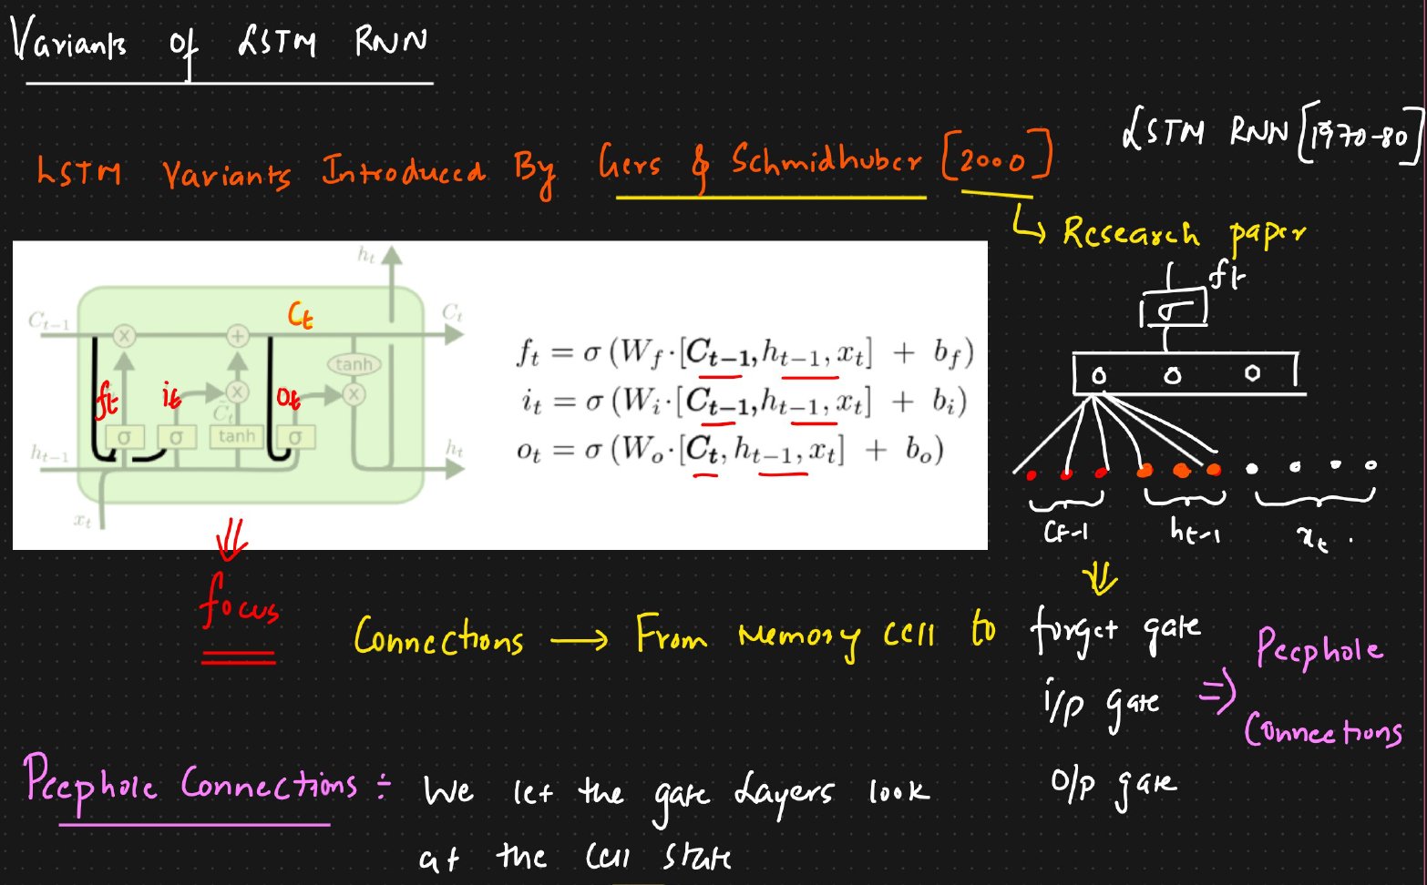

**2. Coupled Input and Forget Gates**

This variant simplifies the LSTM by linking the "forget" and "add" operations together.

* **The Core Idea:** Instead of having two separate gates independently deciding what to forget and what new information to add, this model makes those decisions jointly. The guiding principle is: **"Only add new information when you forget old information."**
* **How it Works:** The model couples the input and forget gates. The amount of new information to add is directly tied to the amount of old information being forgotten.
  + The cell update equation is modified. The new information (candidate memory) is multiplied by (1 - f_t), where f_t is the output of the forget gate.
  + If the forget gate decides to keep everything (f_t = 1), then (1 - f_t) becomes 0, and no new information is added.
  + If the forget gate decides to forget everything (f_t = 0), then (1 - f_t) becomes 1, and the cell is fully updated with new information

**The Benefit:** This creates a more direct trade-off. The network can't add new memories without first making space by forgetting old ones. This can lead to a more efficient and sometimes more stable learning process.

The text also briefly mentions the **Gated Recurrent Unit (GRU)** as another important and popular variant of RNNs, which is an even more simplified version of the LSTM

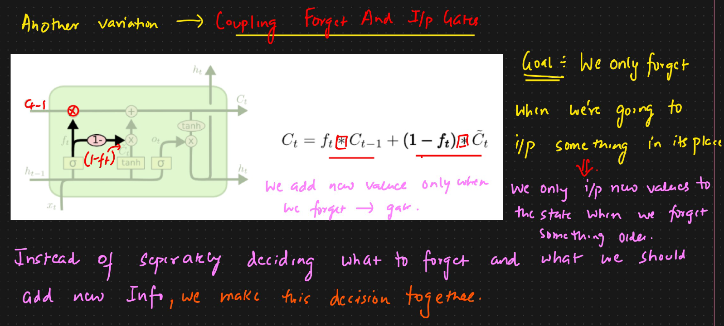

**405:GRU RNN (Gated Recurring neural network):**

The **Gated Recurrent Unit (GRU)** — a **variant of LSTM RNN**, created by **Cho et al. in 2014**.  
While **LSTM (Long Short-Term Memory)** was developed in the 1980s, GRU is a **newer, simpler, and faster version** designed to solve the same problems but with fewer parameters.

Both LSTM and GRU are used to handle **long-term dependencies** in sequential data (like text, audio, or time series).  
However, GRU simplifies the architecture by **merging the long-term and short-term memory into a single unit**.

**Why GRU Was Introduced**

LSTM networks are powerful but have a **complex structure** with:

* Three gates (Forget, Input, Output)
* Two types of memory (Long-term **Cₜ** and Short-term **hₜ**)
* Many weights and biases  
  → which means **more parameters** and **longer training time**.

The GRU was designed to:  
✅ Simplify the architecture  
✅ Reduce training time  
✅ Use fewer parameters while maintaining similar accuracy

**🧩 3. Key Structural Difference Between LSTM and GRU**

| **Concept** | **LSTM** | **GRU** |
| --- | --- | --- |
| Memory | Has **two** memories (Cell State Cₜ and Hidden State hₜ) | Has **one** combined memory (hₜ) |
| Gates | 3 main gates (Forget, Input, Output) | 2 gates (Update, Reset) |
| Complexity | More weights and bias parameters | Fewer parameters, simpler equations |
| Training Speed | Slower | Faster |

**🧠 4. Components of GRU**

GRU has **two main gates** and one **temporary hidden state**:

| **Symbol** | **Gate Name** | **Purpose** |
| --- | --- | --- |
| **zₜ** | **Update Gate** | Controls how much of the past information to keep and how much new information to add |
| **rₜ** | **Reset Gate** | Controls how much of the previous memory to forget |
| **h̃ₜ** | **Candidate (Temporary) Hidden State** | Holds the new information to be added to memory |

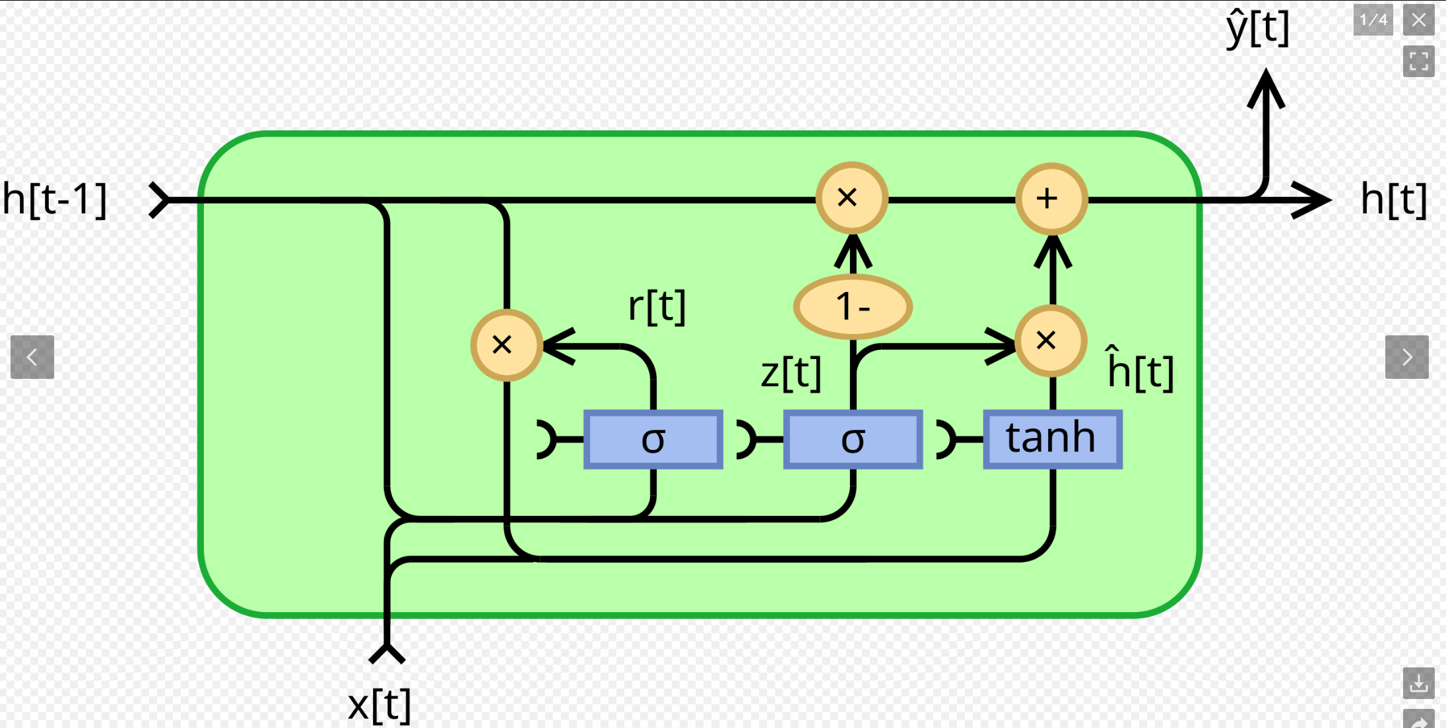

**How the Gates Work Together**

Let’s understand intuitively:

1. **Reset Gate (rₜ):**  
   Decides **what old info to forget**.  
   Example: If a word changes topic, reset earlier context.
2. **Update Gate (zₜ):**  
   Decides **how much of new info to add**.  
   Example: If context is similar, keep old memory; if new context, update.
3. **Candidate Hidden State (h̃ₜ):**  
   Builds a **new representation** using both old memory and current input.
4. **Final Hidden State (hₜ):**  
   Produces output that blends **past** and **current** knowledge smoothly.

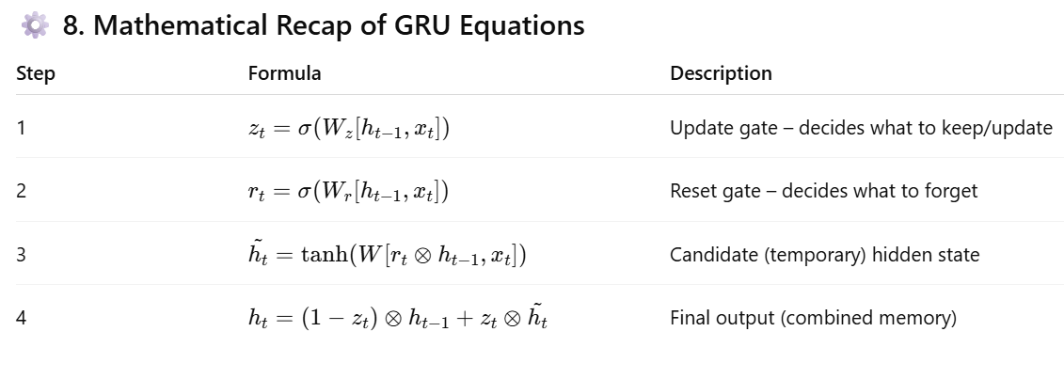

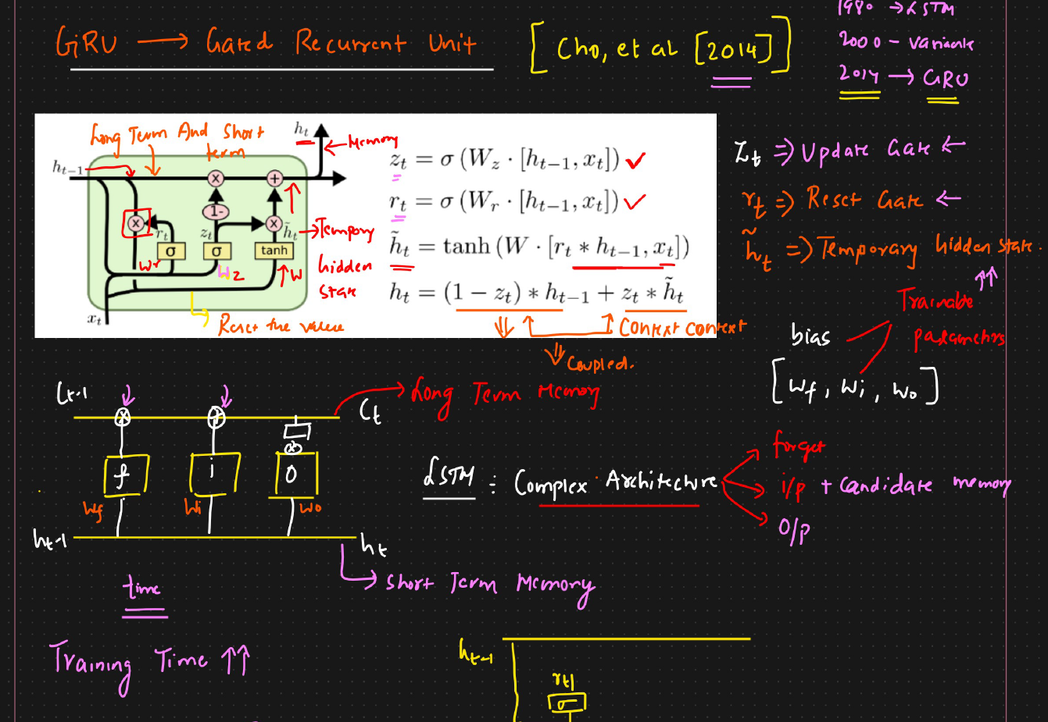

1. **Reset Gate (R_t)**
   * **Calculation**: R_t = sigmoid(W_r * [H_t-1, X_t]) (where [H_t-1, X_t] means concatenating the previous hidden state and current input).
   * **Purpose**: The reset gate determines how much of the *previous hidden state* (H_t-1) should be "forgotten" or "reset" when calculating the new *temporary hidden state*.
   * **Mechanism**: It produces values between 0 and 1. When R_t is close to 0, it effectively "resets" or ignores much of the past information from H_t-1. When R_t is close to 1, it keeps most of the past information.
   * **Example**: The speaker provides a numerical example: if H_t-1 is [0.6, 0.5, 0.3, 0.9] and R_t is [0.2, 0.4, 0.8, 0.2], a point-wise multiplication H_t-1 * R_t would result in [0.12, 0.20, 0.24, 0.18]. This shows that only a percentage (e.g., 20% of 0.6, 40% of 0.5) of the previous hidden state is carried forward, effectively "resetting" the rest. This resetting is context-dependent, based on the current input X_t.
2. **Temporary Hidden State (H_t_hat)**
   * **Calculation**: H_t_hat = tanh(W_h * [R_t * H_t-1, X_t]) (where * is point-wise multiplication).
   * **Purpose**: This is a candidate for the new hidden state. It incorporates the current input X_t and a *reset version* of the previous hidden state (R_t * H_t-1).
   * **Mechanism**: The reset gate's output (R_t) is multiplied with the previous hidden state (H_t-1) *before* being fed into the tanh activation function along with the current input X_t. This ensures that only the relevant parts of the past information are considered for the new candidate state.
3. **Update Gate (Z_t)**
   * **Calculation**: Z_t = sigmoid(W_z * [H_t-1, X_t]).
   * **Purpose**: The update gate determines how much of the *previous hidden state* (H_t-1) to carry over to the current hidden state, and how much of the *new temporary hidden state* (H_t_hat) to incorporate.
   * **Mechanism**: It acts as a "coupling" mechanism, similar to how LSTM couples its forget and input gates.
     + - * If Z_t is close to 1, it means we want to keep most of the new information from H_t_hat and forget most of the old information from H_t-1.
         * If Z_t is close to 0, it means we want to keep most of the old information from H_t-1 and ignore most of the new information from H_t_hat.
4. **Final Hidden State (H_t)**

* **Calculation**: H_t = (1 - Z_t) * H_t-1 + Z_t * H_t_hat.
* **Purpose:** This is the final output of the GRU cell, representing the updated memory that combines past and current information.
* **Mechanism:** This equation clearly shows the "coupling."
  + - (1 - Z_t) * H_t-1: This part decides how much of the *previous hidden state* to retain. If Z_t is high (meaning we want to incorporate new info), (1 - Z_t) will be low, reducing the old info.
    - Z_t * H_t_hat: This part decides how much of the *new temporary hidden state* to incorporate. If Z_t is high, more of the new info is included
    - This coupled approach ensures that when more new information is added, less old information is retained, and vice-versa, making the update process efficient and context-aware.

**Advantages of GRU over LSTM**

* + - **Simpler Architecture**: Fewer gates (two vs. three).
    - **Fewer Trainable Parameters**: Less complexity directly translates to fewer weights and biases.
    - **Faster Training**: With fewer parameters, GRUs generally train faster and require less computational resources compared to LSTMs, while often achieving comparable performance on many tasks.

In essence, GRU simplifies the complex memory management of LSTM by combining the cell and hidden states and using fewer, more integrated gates to control the flow of information, leading to a more efficient model. 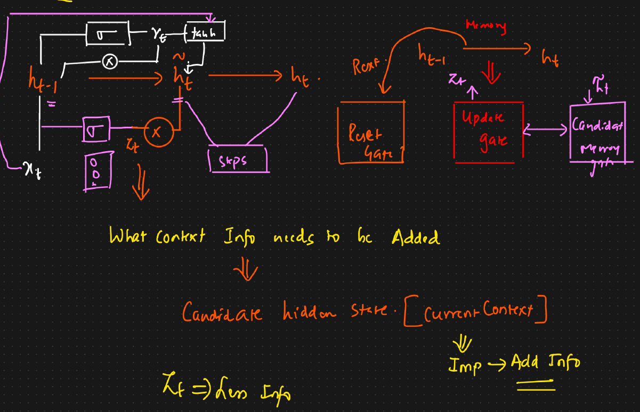

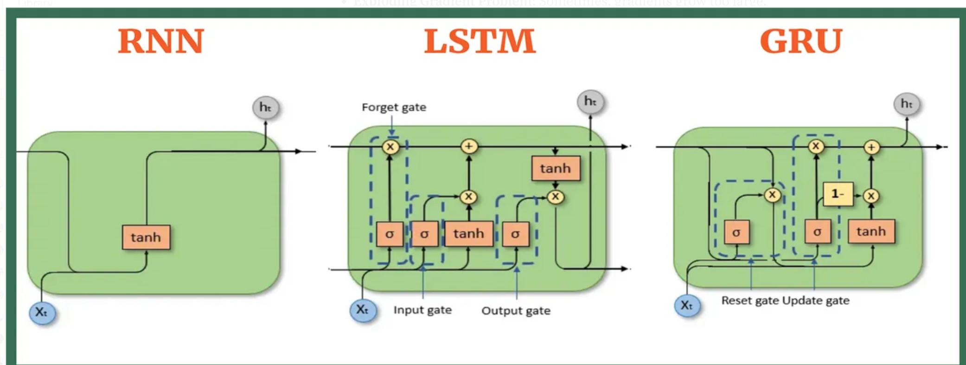

**412:Bidirectional RNN/LSTM RNN:**

**1. Recap of Simple RNNs/LSTMs**

First, the speaker reminds us how a simple RNN or LSTM works.

* **One-Way Street:** These networks process information sequentially, like reading a sentence from left to right.
* **Memory of the Past:** At each step (for each word), the network considers the current word and its "memory" of the previous words.
* **Limitation:** The prediction for a word at a certain position is only based on the words that came before it. It has no knowledge of what's coming next in the sentence.

**2. The Problem: Why Future Context Matters**

The speaker uses a great example to illustrate the limitation of a simple RNN:

**Sentence:** "Krish eats _____ in Bangalore."

* **The Goal:** Predict the missing word (the food).
* **Simple RNN's View:** When the simple RNN reaches the blank space, it has only processed "Krish eats." It has no idea the sentence will end with "in Bangalore." It might predict any common food.
* **The Missing Clue:** The word "Bangalore" is a huge clue! If the network knew this, it might predict a food famous in Bangalore, like "dosa." Similarly, if the sentence was "Krish eats _____ in Paris," the prediction might be "pizza" or "croissant."

This shows that for accurate predictions, the context of the *entire sentence* (both past and future words) is crucial.

**3. The Solution: Bidirectional RNNs**

A Bidirectional RNN solves this problem by processing the sentence in **two directions at once**.Imagine you have two separate RNNs working together:

**1. The Forward RNN:**

* This is a standard RNN that reads the sentence from **left to right** (start to end).
* It gathers context from the past words. For our example, it processes: Krish -> eats -> ___ -> in -> Bangalore.

**2.The Backward RNN:**

* This RNN reads the same sentence but from **right to left** (end to start).
* It gathers context from the future words. For our example, it processes: Bangalore -> in -> ___ -> eats -> Krish.

**4. How They Work Together**

**Combining Knowledge:** At each position in the sentence, the Bidirectional RNN combines the output from *both* the forward and backward RNNs.

**Making a Better Prediction:** When it's time to predict the blank word in "Krish eats _____ in Bangalore":

* + The **forward pass** provides the context of "Krish eats."
  + The **backward pass** provides the context of "in Bangalore."
  + By combining these two pieces of information, the model has a complete picture and can make a much more informed prediction (like "dosa").

In short, a Bidirectional RNN allows the network to have a memory of both the **past** and the **future** for any given point in a sequence, leading to better understanding and more accurate predictions. This technique can be applied to standard RNNs, LSTMs, or GRUs to make them bidirectional.

**4. Types of RNN Architectures (Before Moving to Bidirectional)**

The instructor explains different RNN types based on how inputs and outputs are structured:

| **Type** | **Description** | **Example** |
| --- | --- | --- |
| **1-to-1 RNN** | One input → One output | Simple image classification |
| **1-to-Many RNN** | One input → Multiple outputs | Image captioning (one image → multiple words) |
| **Many-to-1 RNN** | Many inputs → One output | Sentiment analysis (many words → one sentiment) |
| **Many-to-Many RNN** | Many inputs → Many outputs | Language translation, speech-to-text |
|  |  |  |

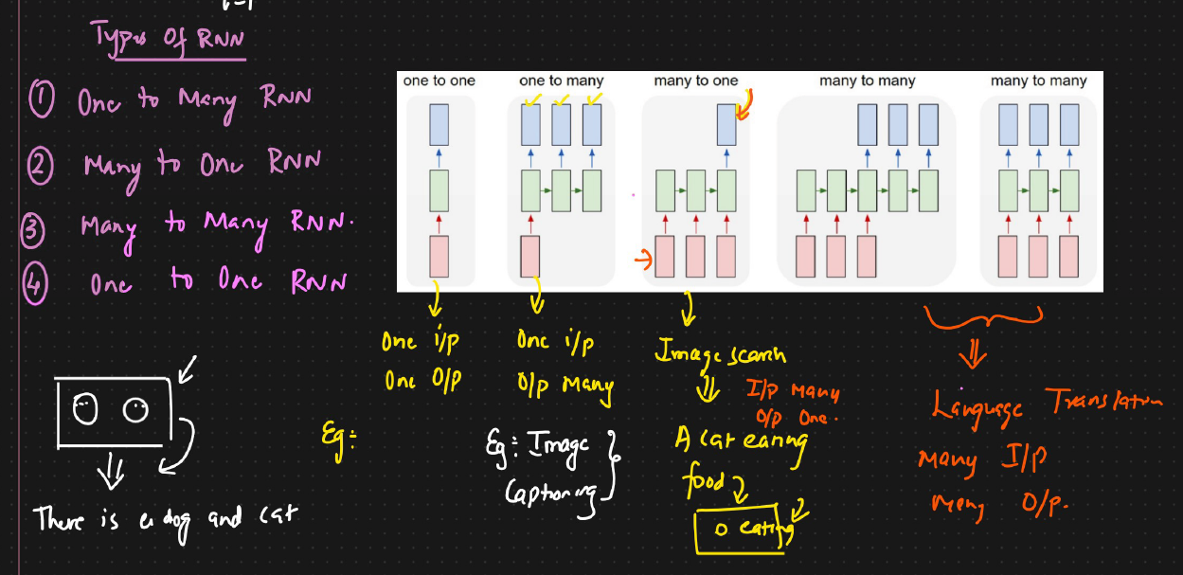

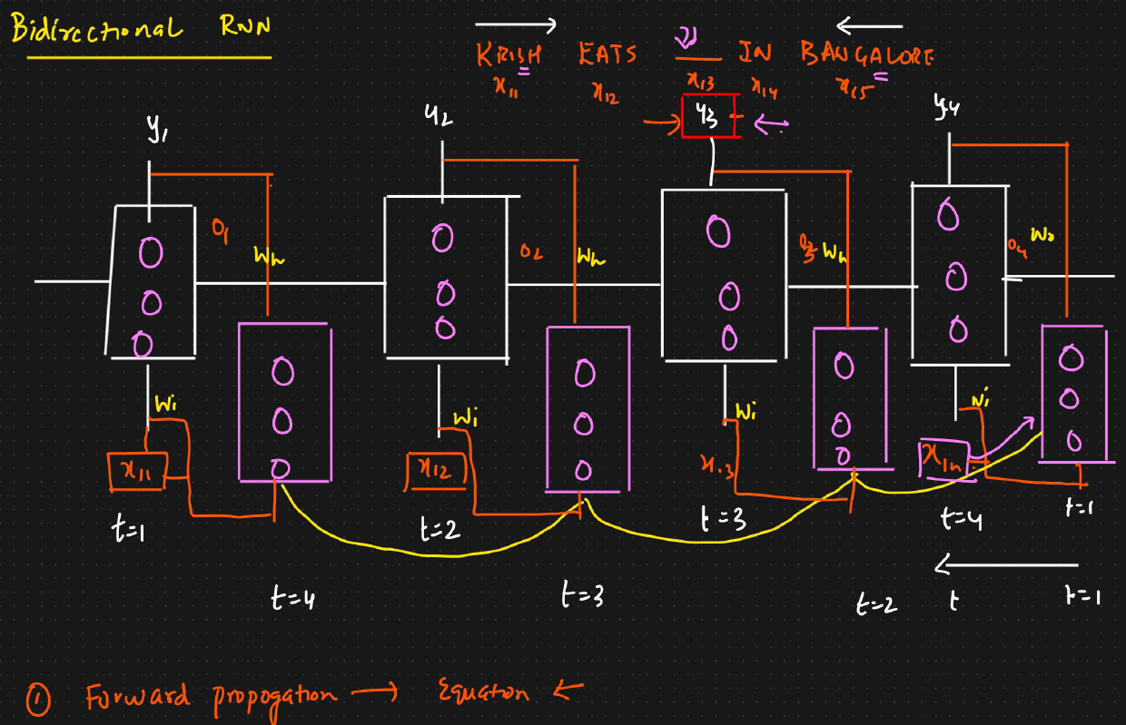

**🔄 6. How Bidirectional RNN Works**

A **Bidirectional RNN** runs **two RNNs simultaneously**:

1. **Forward RNN** → processes the sequence from **start to end** (left to right)  
   Example: Krish → eats → in → Bangalore
2. **Backward RNN** → processes the sequence from **end to start** (right to left)  
   Example: Bangalore → in → eats → Krish

At each time step:

* The outputs from both RNNs (forward + backward) are **combined** (concatenated).
* This merged information gives **complete context** (past + future).
* The final combined output is used for prediction.

In the bidirectional RNN/LSTM RNN, A word is sent to neuron at timestamp and at next timestamp another word is sent and as RNN as long term memory/feedback loop it can store the pervious timestamp word as well but due to this process we will not have the context of future word and this causes problem when we want to predict next word.

Eg : Raj likes to eat _________ in Tirupathi

Raj likes to eat ________ in Paris

To solve this problem we will also send the words in backward direction as well , so that the word which is in middle can get context of pervious words as well as future words as well

**413:Encoder and Decoder:**

**Simple RNN 🡪** It has vanishing gradient descent problem

**LSTM/GRU RNN 🡪** It cannot store the context of future words and also does not solve sequence to sequence use cases ( Many to many )

**Examples of "Many-to-Many" Problems:**

* **Machine Translation:** Translating "How are you" (3 words in English) to "Comment allez-vous" (3 words in French). Or "Thank you" (2 words) to "Gracias" (1 word in Spanish).
* **Chatbots:** Taking a user's message like "Hi, how are you?" and generating a suggested reply like "I am doing well, thanks!".

For these complex tasks, a more advanced architecture is needed.

**The Solution: The Encoder-Decoder Architecture**

The Encoder-Decoder model is designed specifically for these sequence-to-sequence tasks. It consists of two main components working together:

1. **The Encoder:** Its job is to read and understand the entire input sentence.
2. **The Decoder:** Its job is to take the Encoder's understanding and generate the output sentence.

Let's break down how each part works, using the example of translating "thank you" to "gracias".

**1. The Encoder: Reading the Input**

The Encoder's only goal is to process the input sentence ("thank you") and compress all its meaning into a single, fixed-size numerical representation. This representation is called the **Context Vector**.

* **How it works:** The Encoder is usually an LSTM or GRU network.
* **Step 1: Prepare the Input:** Special tokens are added to the sentence to mark its beginning and end. So, "thank you" becomes [<start>, "thank", "you", <end>].
* **Step 2: Process Word by Word:** The Encoder reads the sentence one word at a time. At each step, it updates its internal "memory" (its hidden state and cell state).
* **Step 3: Create the Context Vector:** After reading the final word (<end>), the Encoder's final memory state is the **Context Vector**. Think of this vector as a "thought" or a summary that captures the complete meaning of "thank you". The Encoder produces no other output; its only product is this context vector.

**2. The Decoder: Generating the Output**

The Decoder's job is to take the Context Vector and generate the output sentence ("gracias") word by word.

* **How it works:** The Decoder is also an LSTM or GRU network.
* **Step 1: Initialization:** The Decoder is initialized with the **Context Vector** from the Encoder. This gives the Decoder all the information it needs about the input sentence.
* **Step 2: Start Generating:** To kick things off, the Decoder is given a <start> token as its first input.
* **Step 3: Predict the First Word:** Using the context vector and the <start> token, the Decoder predicts the *next* word in the output sequence. In our example, it should predict "gracias". This prediction is done using a softmax layer, which gives a probability for every possible word in the target language's vocabulary. The word with the highest probability is chosen.
* **Step 4: Feed the Output Back In:** The predicted word ("gracias") is then fed back as the input for the *next* time step.
* **Step 5: Predict the Next Word:** The Decoder now uses the context vector and its previous prediction ("gracias") to predict the next word. Since "gracias" is a complete translation, the model should now predict the <end> token.
* **Step 6: Stop Generating:** When the Decoder predicts the <end> token, the generation process stops. The final output is the sequence of words generated before the <end> token.

**Training the Model**

* During training, the model already knows the correct translation (the "ground truth").
* The Encoder processes the input ("thank you") to create the context vector.
* The Decoder is given the context vector and the <start> token. It tries to predict the first word.
* The model compares its prediction (e.g., it might have predicted "hello") with the correct word ("gracias").
* It calculates the error (loss) between its prediction and the correct word.
* This error is used to adjust all the weights in both the Decoder and the Encoder through a process called **backpropagation**.
* This process is repeated for the entire sequence and for thousands of sentence pairs, allowing the model to learn how to translate correctly.

In summary, the **Encoder** creates a meaningful summary of the input sequence, and the **Decoder** uses that summary to generate the corresponding output sequence, one step at a time.

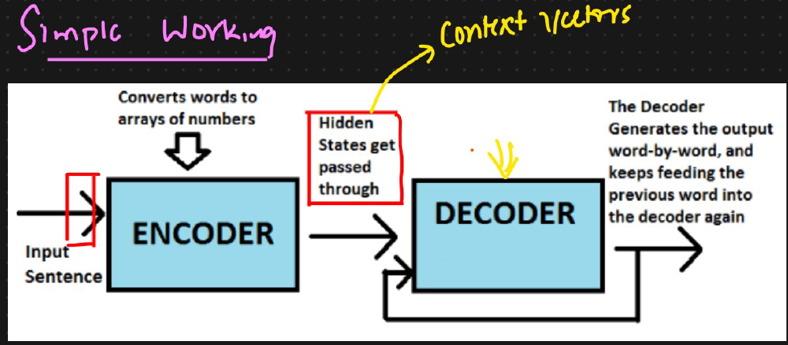

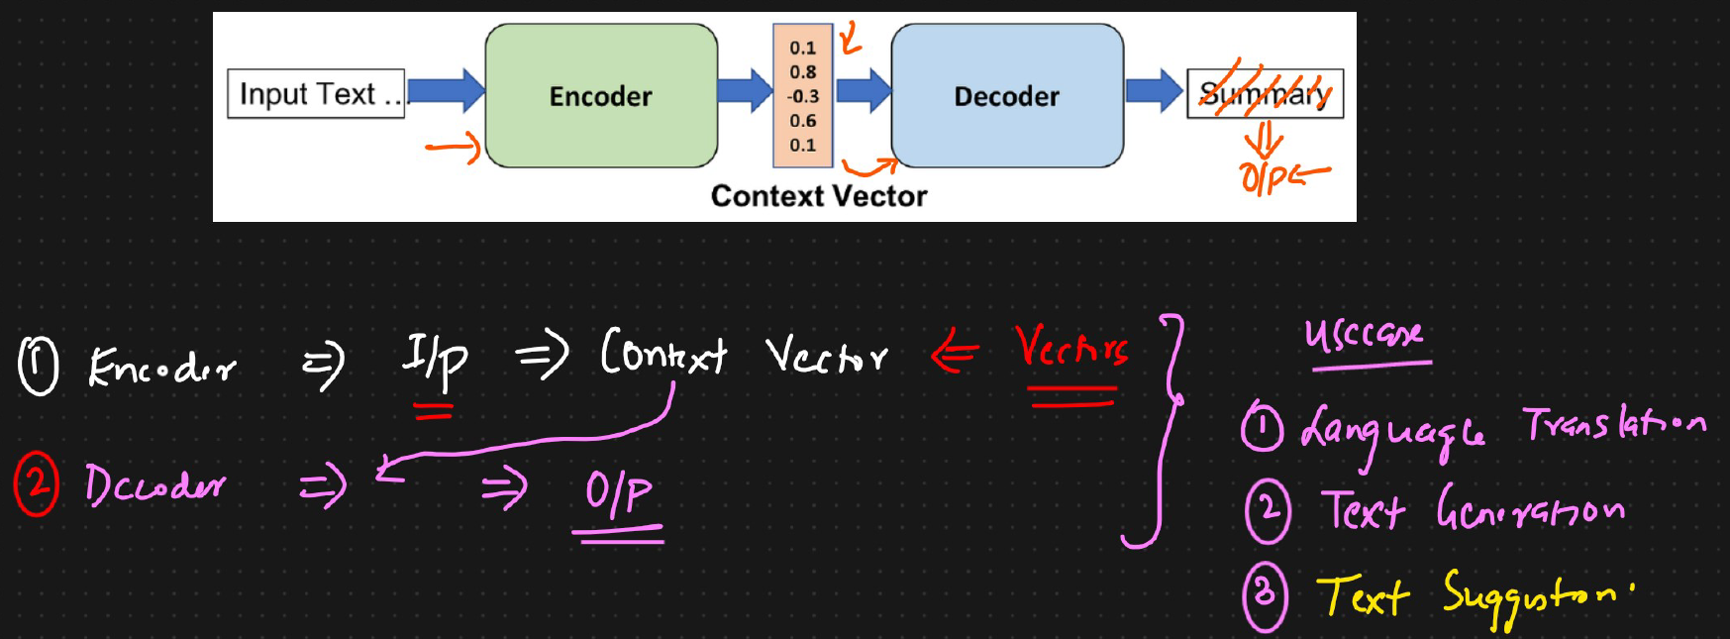

Input sequence of words which are then converted into array of numbers are passed to ENCODER and then a hidden state is created called as **CONTEXT VECTOR** and this is forwarded to decoder layer. Decoder layer generates output word-by-word and keeps feeding the pervious word into the decoder layer again

1. Encoder => I/P => Entire context in form of vectors ( Conext vectors )

2. Decoder => Context Vector => Output

In both encoder and decoder we will have LSTM RNN ( NOT RNN ).

**Dataset**

**English French**

**Thank you Gracias**

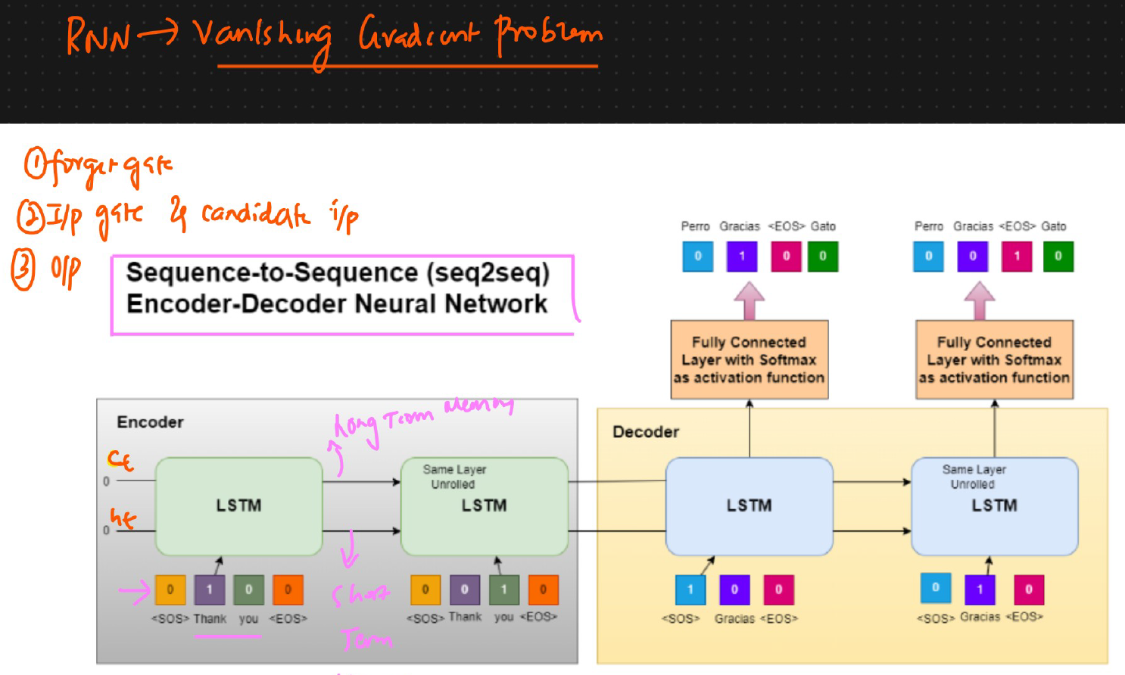

**Encoder**:

In the **encoder** we will be passing the entire sentence along with the special token at start and end of the sentence

**Input sequence: [SOS] → [Thank] → [You] → [EOS]**

**Output sequence: [SOS] → [Gracias] → [EOS]**

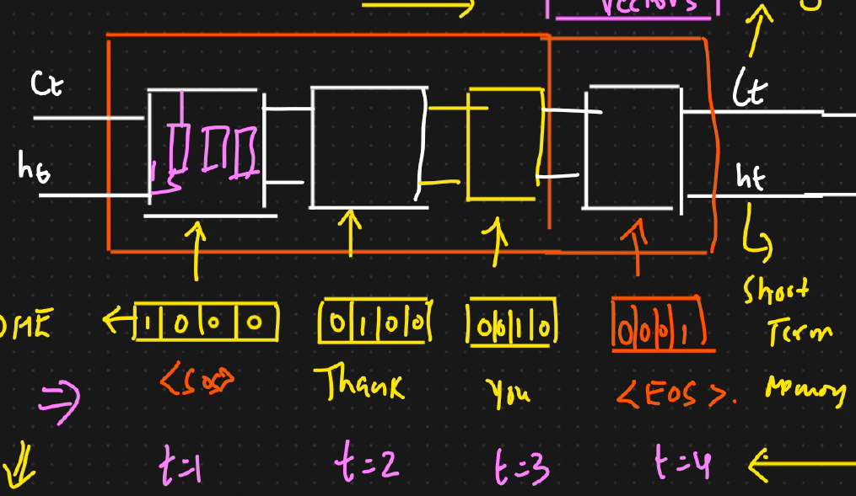

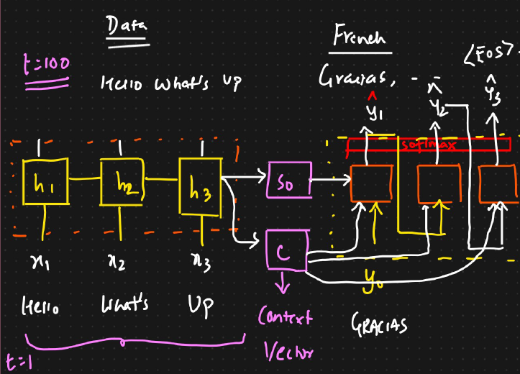

Thank you is converted into vector

At time t1 **SOS** will be the input to LSTM and t2 we will have **thank** at t3 it will be **you** and t4 it will be **EOS** and then we will get short term memory **ht** and long term memory **ht**

**Short term memory + Long term memory => Context vectors**

**Decoder**

Entire **ct & ht** is passed to decoder LSTM. At first we will be pass [SOS] and this output is passed to fully connected layer of SoftMax activation . We use softmax as the output is multiclass classification . The output we may get [0.1,0.6,0.3] and the max value in this vector , if it is 0.5 **gracious** ( because of second word has highest probability )

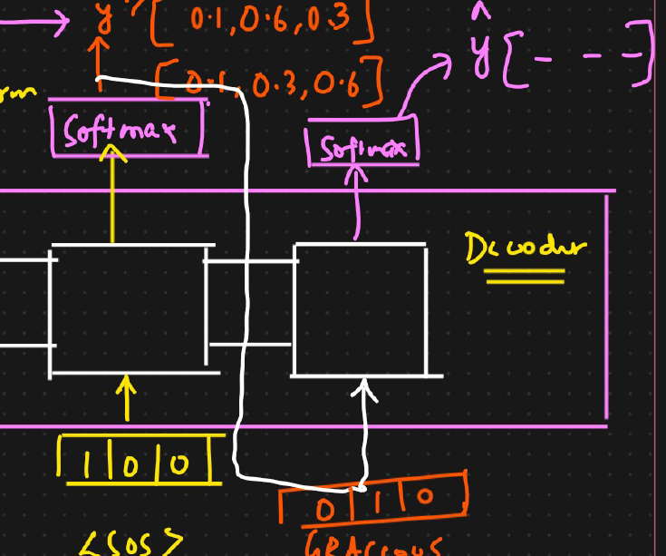

**Forward and Backward Propagation**

* **Forward Propagation:**  
  Passes words through encoder → decoder → predicts output sequence.
* **Backward Propagation (Training):**  
  Calculates loss between predicted output (ŷ) and actual output (y):

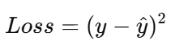

or cross-entropy loss.

Then updates weights in both encoder and decoder via **optimizers** (like Adam or SGD).

**🧩 11. Role of the Context Vector**

The **Context Vector** acts as the bridge between Encoder and Decoder.  
It holds:

* Compressed information of the entire input sentence
* Semantic meaning and word relationships

Example:

For input “Thank you,” the context vector might encode that it’s an **expression of gratitude** — this meaning helps generate “Merci” in French.

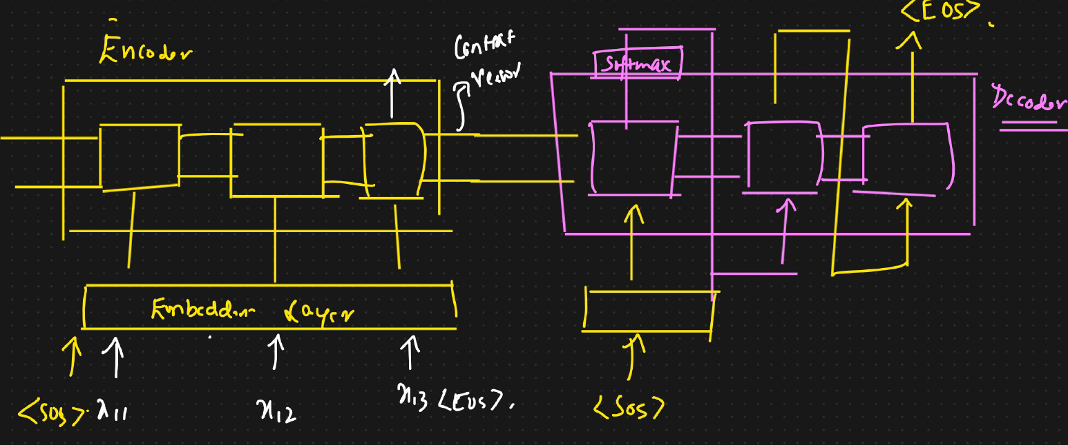

**2. Quick Recap of Encoder–Decoder Architecture**

Before discussing the problem, let’s recall how a typical **Encoder–Decoder (Sequence-to-Sequence)** model works:

1. The **Encoder** (usually made up of LSTM units) reads the entire input sentence word by word.
2. It generates a **Context Vector** — a numerical representation of the whole input sentence.
3. This Context Vector (which combines the last hidden state and cell state from the encoder) is passed to the **Decoder**.
4. The **Decoder** (also made of LSTMs) takes this Context Vector and predicts the output sequence, one word at a time.
5. The output passes through a **Softmax layer** to produce probabilities for each word.

✅ Works fine for short sentences.  
❌ Struggles for long or complex ones.

**The Big Problem: The "Context Vector Bottleneck"**

The text then dives into the main issue with this standard Encoder-Decoder architecture:

* **The Single Context Vector:** The entire meaning of the input sentence, no matter how long, must be squeezed into a *single, fixed-size context vector*.
* **Works for Short Sentences:** For short sentences (e.g., 5-10 words), this context vector is usually sufficient to capture all the necessary information.
* **Fails for Long Sentences:** However, when sentences become very long (e.g., 30, 50, or 100 words), this single context vector becomes a **bottleneck**. It simply cannot hold all the detailed information from the entire sentence.
  + **Information Loss:** The Encoder, as it processes words sequentially, tends to "forget" information from the beginning of a very long sentence by the time it reaches the end. The context vector ends up being heavily influenced by the *most recent* words, while earlier words' context gets diluted or lost.
  + **Empirical Evidence:** Researchers observed this problem by plotting a graph of "sentence length" versus "accuracy" (measured by something called the BLEU score, which evaluates translation quality). They found that as sentence length increased beyond a certain point, the accuracy of the translations significantly decreased.

**The Solution: Introducing the Attention Mechanism**

* The text concludes by stating that this problem of the "context vector bottleneck" for long sentences is a major limitation. To fix this, a new and powerful mechanism is needed: the **Attention Mechanism**.
* **The Idea:** Instead of forcing the entire input sentence into a single context vector, the Attention Mechanism allows the Decoder to "look back" at different parts of the input sentence at each step of generating the output. It essentially gives "additional context" to the Decoder.

**8. Summary of the Problem**

| **Issue** | **Description** |
| --- | --- |
| **Single Context Vector Bottleneck** | The entire input meaning is stored in one vector (from last encoder output). |
| **Loss of Early Information** | Initial words contribute less to final context as sequence length increases. |
| **Poor Long Sentence Handling** | BLEU score drops as sentence length increases. |
| **Limited Representation Power** | One vector can’t fully capture long, complex relationships. |

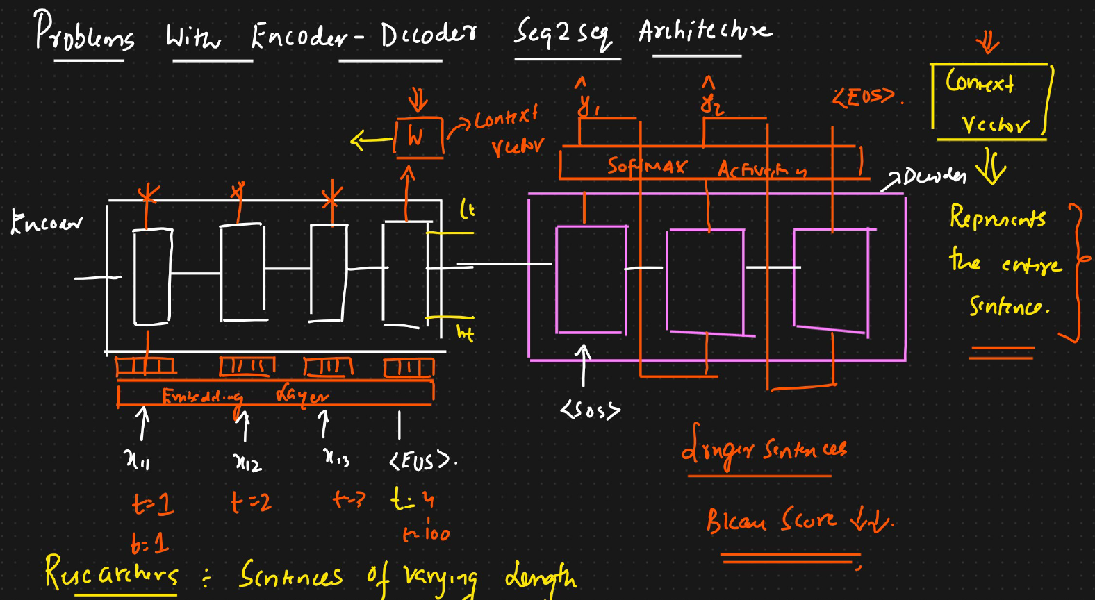

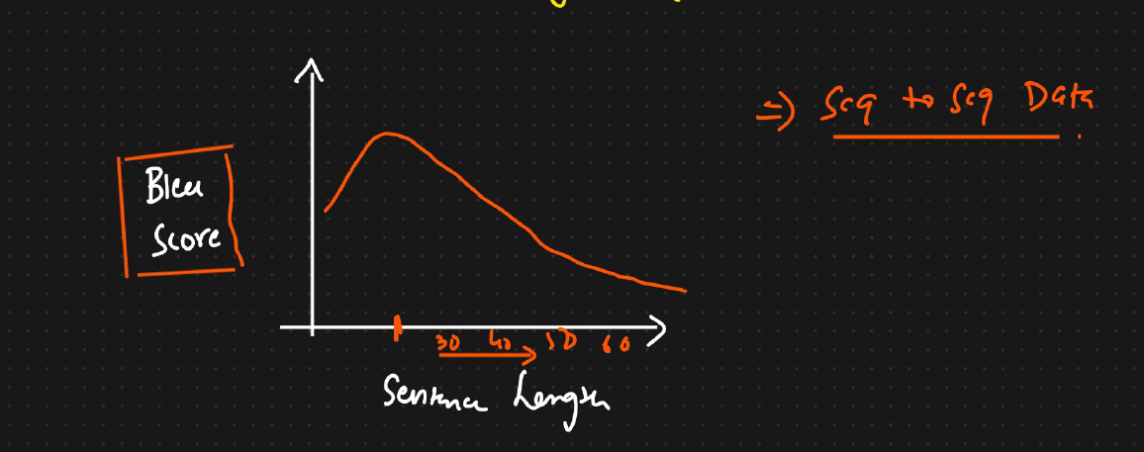

**415:Attention mechanism seq2seq mechanism:**

**The Solution: The Attention Mechanism**

The **Attention Mechanism** was created to solve this exact problem. The main idea is to allow the decoder to "look back" at the *entire* input sentence at every step of its translation process and "pay attention" to the most relevant words for the specific word it's about to generate.

Here’s how it works, broken down step-by-step:

**1. A Smarter Encoder**

Instead of a simple one-way reader, the attention model uses a **bidirectional RNN/LSTM**. This means it reads the input sentence both forwards (from start to end) and backwards (from end to start).

* **Why?** This gives every word a richer representation. For the word "up" in "What's up", the model knows about "What's" (from the forward pass) and also knows it's the last word (from the backward pass).
* **Output:** Instead of producing just one final context vector, this encoder produces a rich annotation (a hidden state) for *every single word* in the input sentence. We now have a collection of vectors,each representing an input word in the context of the whole sentence

**2. A More Powerful Decoder**

This is where the "attention" happens. For each word the decoder is about to generate, it performs a three-step process to create a custom, highly relevant context vector.

Let's say we are translating "Hello what's up" and the decoder is trying to figure out the first French word.

* **Step 1: Calculate Alignment Scores**
  + The decoder looks at its current state (which contains information about what it has translated so far).
  + It then compares its current state with the annotation for *every word* from the encoder ("Hello", "what's", "up").
  + This comparison produces a "score" for each input word. The score indicates how relevant that input word is for generating the *next* output word. This is often done using a small neural network.
* **Step 2: Calculate Attention Weights**
  + The scores from Step 1 are put through a **softmax** function.
  + This turns the scores into percentages (or weights) that all add up to 100%. These are the **attention weights**.
  + For example, to generate the first French word, the attention weights might be: Hello (70%), what's (20%), up (10%). This means "Hello" is the most important word to pay attention to right now.
* **Step 3: Create the Custom Context Vector**
  + A new, dynamic context vector is created by taking a weighted average of all the input word annotations from the encoder. The weights used are the attention weights we just calculated.
  + Context = (70% * annotation_for_Hello) + (20% * annotation_for_what's) + (10% * annotation_for_up)
  + This new context vector is tailored specifically for generating the current output word.

**3. Generate the Output Word**

The decoder takes this new, custom-made context vector (along with its own internal state) and uses it to predict the next word in the output sentence.

This entire process (Steps 1-3) is **repeated for every single word** the decoder generates. When it's time to generate the second French word, it will create a brand new set of attention weights and a new context vector, perhaps paying more attention to "what's" this time.

**Summary**

In short, the attention mechanism gives the model a way to focus on different parts of the input sentence at different stages of the output generation. It doesn't rely on a single, compressed summary. Instead, it creates a new, specialized summary at each step, allowing it to handle long, complex sentences much more effectively and produce significantly better translations. This was a foundational concept that led to even more powerful models like Transformers.

In encoder we will use bidirectional LSTM and the output of each neuron is then passed to softmax activation function using feed forward neural network get output vector ( a11,a12,a13).From each neuron we will also have context which is passed to hidden state **So** and the context vector **C**. All this is a Alignment score

Attention weights is all about how much context we need to provide to decoder inorder to do specific prediction

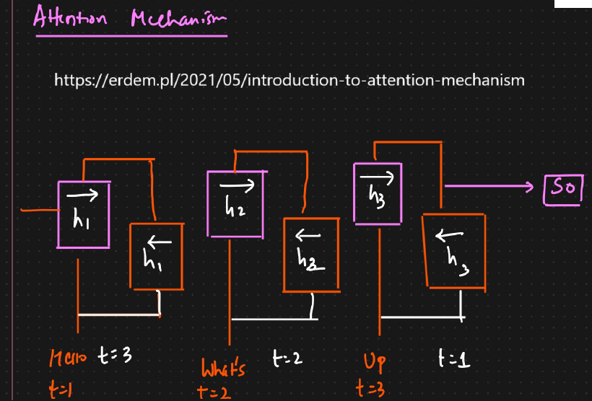

We then create attention weights by taking the **weight** of each neuron with the **output of SoftMax activation** by performing **pointwise multiplication operation** . This output will help in how much context each neuron we should consider from stage to another stage. The output of all these vectors are taken and then perform pointwise addition operation to compute context vector with the actual context vector

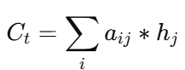

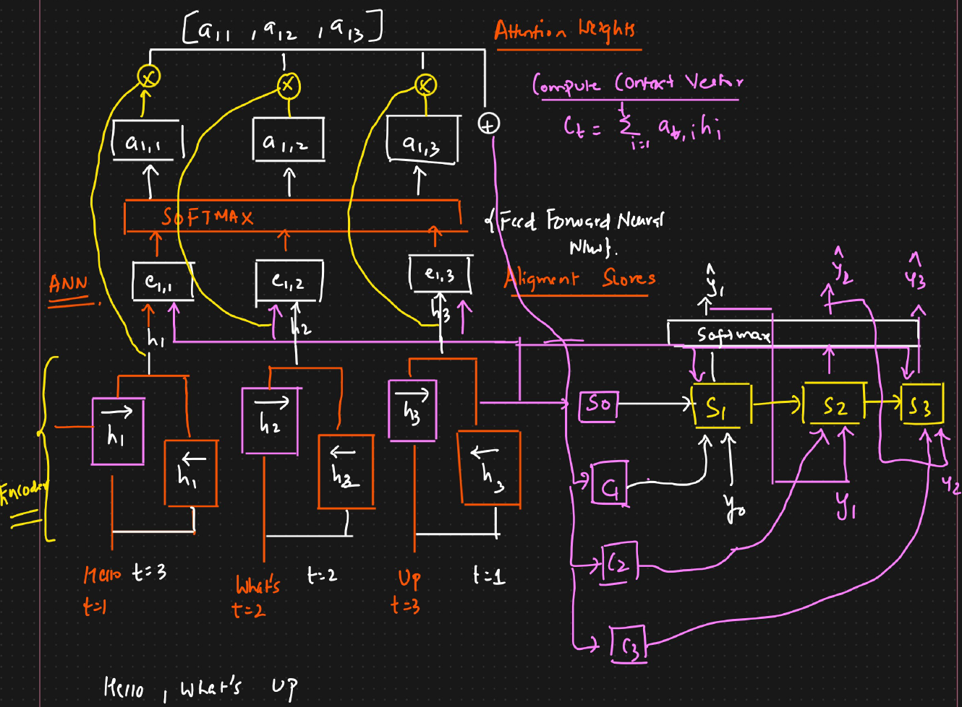

**In Decoder 🡪** To the decoder we will pass hidden state **So** and along with context vector **C1** from encoder to first LSTM in decoder. We will also pass Y0 to the first neuron (S1) and this output is then sent to SoftMax activation function and finally we will get **ŷ1** and then we will pass to next neuron S2 along with output from first neuron and S2 will also receive context from new context vector C2 from encoder which has update context of S1 along with contexts that were generated from encoders each neurons. This way in the second neuron in decoder will have context of first neuron and also updated context from encoder context vector

In simple whenever decoder is calculating the output, we are also going and calculating the context vector again ( which means encoder neurons are getting activated again )

BLEU score for longer sentences prediction is also good with seq2seq attention mechanism